Department of Chemistry

Exam Questions for CfE Higher Chemistry

Chemistry in Society
- Getting the Most from Reactants/ Equlibria
- Chemical Energies/ Oxidation and Reduction

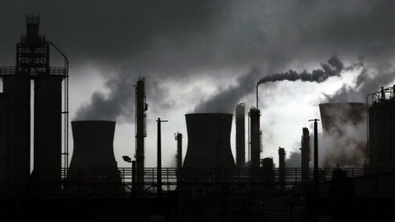

Contents

2.1 Getting the Most from Reactants | Page 4
2.2 Equlibria | Page 21
2.3 Chemical Energies | Page 28
2.4 Oxidising and Reducing Agents | Page 31

2.1 Getting the Most from Reactants
Summary

What you should know from previous National 5 work-
- Balancing equations
- n=CV
- n=m/GFM
- Enthalpy of combustion:
E_{h}=cm∆T
- A bomb calorimeter is an accurate way of measuring the enthalpy of combustion
- Oxidation is the loss of electrons
- Reduction is the gain of electrons
- A displacement reaction is where a metal replaces another metal in solution

Industrial Chemistry
Terms:
- Raw material eg. Crude oil
- Feedstock- a raw material which has been through a process eg. Petrol (crude oil has gone through fractional distillation)
- By-products- other products which could be sold on or recycled
- Yield- the amount of product which is produced calculated by the equation (covered later in Unit 3):
$$\% yield=\frac{amount of product actually formed}{amount of product which was calculated}x100$$
Making Products:
- There are two processes for making chemical batch process and continuous process
- Batch process means that the reaction is carried out then the reaction vessel needs to stop and be cleaned out, it has obvious draw backs but is useful for speciality medicines.
- Continuous process can run 356 days a year, 24 hours a day. This would be used if large amounts of product were required.
Going from the lab to industry:
- There are several steps involved in making new drugs:
Research and development laboratory process pilot plant production plant
Decided best synthesis small scale medium scale Large scalereview and improve route health and safety investigated

Building the plant:
Factors to consider are:
- Availability, sustainability and cost of feedstock- closer and cheaper are better
- Opportunities to recycle-this is where unused reactants are fed back into the reaction vessel
- Energy requirements- exothermic reactions are better as it saves costs. Catalysts are also good.
- Use of by-products- other products can be sold on
- Yield of product- higher yield is better
Environmental consideration:
- How can waste be minimised
- Can we avoid making toxic substances
- Can we design biodegradable products and by-products

Calculations from equations
- Working out the mass a product made can only be done by comparing the number of moles
- Moles can be worked out using the calculations
  - If a solid n=m/GFM
  - If a liquid n=cv
  - If a gas 1mol≈24litres (at standard temperature and pressure)
Steps:
- READ THE QUESTION: be aware these questions have many avenues but the same basic plan
- Write a balanced equation
- Identify two chemicals mentioned in the question (re-write using only these two)
- Calculate the number of moles known substance
- Use mole ratio to calculate the number of moles of other substance
- Use an above calculation to work out the final mass, concentration or volume.

Example 1 calculation involving mass:
Calculate the mass of water produced when 320g of methane is burned according to the following equation.
CH₄ + 2O₂ CO₂ + 2H₂O balance equation
1 x CH₄ 2 x H₂O identify chemicals mentioned in question
n=m/GFM calculate number of moles of known substance
=320/16
=20moles 40moles use mole ratio to work out moles of other substance
m=n x GFM
=40 x 18
= 720g of H₂O work out final mass

Example 2 calculation involving volumes and concentration:
Calculate the concentration of hydrochloric acid (HCl) used if 20cm³ of the acid was neutralised by 10cm³ of 1moll⁻¹ of sodium hydroxide (NaOH).
HCl + NaOH H₂O + NaCl balance equation
1 x NaOH 1 x HCl identify chemicals mentioned in question
n=cv calculate number of moles of known substance
= 1 x 0.01
=0.01moles 0.01moles use mole ratio to work out moles of other substance
c=n/v
=0.01/0.02
= 0.5moll⁻¹ of HCl work out final concentration

Example 3 calculation involving volume of gas
Calculate the volume of hydrogen gas produced when 2.4g of magnesium react with excess hydrochloric acid.
Assume the molar volume of hydrogen is 23moll⁻¹
Mg + 2HCl MgCl₂ + H₂ balance equation
1 x Mg 1 x H₂ identify chemicals mentioned in question
n=m/GFM calculate number of moles of known substance
= 2.4 x 24
= 0.1moles 0.1moles use mole ratio to work out moles of other substance
1mol >23litres
0.1mol> 2.3mol of H₂ work out final volume

Excess calculation:
- Excess calculations have an extra step which follows after the balanced equation
- In an excess calculation you will be told about both reactant and the first step is to work out which is in excess (the one which there is too much of)
- The reactant in excess is discarded and you follow the rest of the steps as normal
Excess calculation steps:
- Balance the equation
- Work out the number of moles of each reactant
- Identify which is in excess and discard it
- Use mole ratio to calculate the number of moles of other substance
- Use an above calculation to work out the final mass, concentration or volume.

Excess example:
A piece of aluminium weighing 2.7g was added to 100cm³ of 2 moll⁻¹ hydrochloric acid. The equation of the reaction is shown below. Work out the volume of gas of hydrogen produced (the molar volume of hydrogen is 24litres mol⁻¹)
2Al + 6HCl 2AlCl₃ + 3H₂ balance equation
Excess:
n of Al= n of HCl=cv work out moles of each reactant
=2.7/27 =2 x 0.1
=0.1moles =0.2moles
Using molar ratio: work out which is in excess
0.1moles of Al needs 0.6moles of HCl so Al is in excess
6 x HCl 3 x H₂
0.2moles of HCl 0.1moles of H₂ use mole ratio to work out moles of other substance
1mole > 24litres
0.1moles > 2.4 litres work out final volume

Percentage Yield and Atom Economy
Percentage Yield:
- Percentage yield is a ratio of the amount of product actually made, divided by the amount of product which should have been made
- The amount which should have been made, the theoretical yield, is calculated using balanced equations, like we have seen before.
- The equation is in the data book as:
$$\% yield=\frac{amount of product actually formed}{amount of product which was calculated}x100$$
- The percentage yield is used to give an indication of how effective a process is, this is used in industry to determine costing of the reaction

Atom economy:
- Atom economy is similar to percentage yield but instead of focusing on how much reactant is converted into product if focuses on the overall conversion of reactants to products, taking into account waste.
- This is a key part of green chemistry, because as ideally there is as little waste as possible (or a high atom economy)
- Atom economy is worked out using the following equation:
$atom economy=\frac{mass of desired product\left(s\right)}{total mass of reactants}x100$

Getting the most from reactants questions

1. A mixture of potassium chloride and potassium carbonate is known to contain
0·1 mol of chloride ions and 0·1 mol of carbonate ions. How many moles of potassium ions are present?
A 0·15
B 0·20
C 0·25
D 0·30

2. Which of the following gas samples has the same volume as 7 g of carbon monoxide?
(All volumes are measured at the same temperature and pressure.)
A 1 g of hydrogen
B 3.5 g of nitrogen
C 10 g of argon
D 35 . 5 g of chlorine

3. Which of the following has the largest volume under the same conditions of temperature and pressure?
A 1 g hydrogen
B 14 g nitrogen
C 20·2 g neon
D 35·5 g chlorine

4. The equation for the complete combustion of propane is:
C₃H_{8(g)} + 5O_{2(g)} → 3CO_{2(g)} + 4H₂O_{(l)}
30cm³ of propane is mixed with 200cm³ of oxygen and the mixture is ignited. What is the volume of the resulting gas mixture? (All volumes are measured at the same temperature and pressure.)
A 90cm³
B 120cm³
C 140cm³
D 210cm³

5. 20cm³ of butane is burned in 150 cm³ of oxygen.
C₄H_{10(g)} + 6O_{2(g)} → 4CO_{2(g)} + 5H₂O_{(g)}
What is the total volume of gas present after complete combustion of the butane?
A 80cm³
B 100cm³
C 180cm³
D 200cm³

6. 2NO_{(g)} + O_{2(g)} → 2NO_{2(g)}
How many litres of nitrogen dioxide gas could theoretically be obtained in the reaction of 1 litre of nitrogen monoxide gas with 2 litres of oxygen gas? (All volumes are measured under the same conditions of temperature and pressure.)
A 1
B 2
C 3
D 4

7. 2NO_{(g)} + O_{2(g)} → 2NO_{2(g)}
How many litres of nitrogen dioxide gas would be produced in a reaction, starting with
a mixture of 5 litres of nitrogen monoxide gas and 2 litres of oxygen gas? (All volumes are measured under the same conditions of temperature and pressure.)
A 2
B 3
C 4
D 5

8. What volume of oxygen (in litres) would be required for the complete combustion of a
gaseous mixture containing 1 litre of carbon monoxide and 3 litres of hydrogen?
(All volumes are measured at the same temperature and pressure.)
A 1
B 2
C 3
D 4

9. 2C₂H_{2(g)} + 5O_{2(g)} → 4CO_{2(g)} + 2H₂O_{(l)}
ethyne
What volume of gas would be produced by the complete combustion of 100 cm3 of ethyne gas? All volumes were measured at atmospheric pressure and room temperature.
A 200 cm³
B 300 cm³
C 400 cm³
D 800 cm³

10. 20cm3 of ammonia gas reacted with an excess of heated copper(II) oxide.
3CuO + 2NH₃ → 3Cu + 3H₂O + N₂
Assuming all measurements were made at 200 °C, what would be the volume of gaseous
products?
A 10cm³
B 20cm³
C 30cm³
D 40cm³

11. Calcium carbonate reacts with nitric acid as follows.
CaCO_{3(s)} + 2HNO_{3(aq)} → Ca(NO₃)_{2(aq)} + H₂O_{(l)} + CO_{2(g)}
0·05 mol of calcium carbonate was added to a solution containing 0·08 mol of nitric acid. Which of the following statements is true?
A 0·05 mol of carbon dioxide is produced.
B 0·08 mol of calcium nitrate is produced.
C Calcium carbonate is in excess by 0·01 mol.
D Nitric acid is in excess by 0·03 mol.

12. A mixture of magnesium bromide and magnesium sulfate is known to contain 3 mol
of magnesium and 4 mol of bromide ions. How many moles of sulfate ions are present?
A 1
B 2
C 3
D 4

13. 5 g of copper is added to excess silver nitrate solution. The equation for the reaction that takes place is:
After some time, the solid present is filtered off from the solution, washed with water,
dried and weighed. The final mass of the solid will be
A less than 5 g
B 5g
C 10g
D more than 10 g.

14. A pupil added 0·1 mol of zinc to a solution containing 0·05 mol of silver(I) nitrate.
Zn_{(s)} + 2AgNO_{3(aq)} → Zn(NO₃)_{2(aq)} + 2Ag_{(s)}
Which of the following statements about the experiment is correct?
A 0·05 mol of zinc reacts.
B 0·05 mol of silver is displaced.
C Silver nitrate is in excess.
D All of the zinc reacts.

15. 0·5 mol of copper(II) chloride and 0·5 mol of copper(II) sulphate are dissolved together in water and made up to 500 cm3 of solution. What is the concentration of Cu²⁺_{(aq)} ions in the solution in mol l^{–1}?
A 0·5
B 1·0
C 2·0
D 4·0

16. 10 g of magnesium is added to 1 litre of 1 mol l^{–1} copper(II) sulphate solution and the
mixture stirred until the reaction is complete. Which of these is a result of this reaction?
A All the magnesium reacts.
B 63 . 5 g of copper is displaced.
C 2 mol of copper is displaced.
D The resulting solution is colourless.

17. Ammonia is manufactured from hydrogen and nitrogen by the Haber Process.
3H_{2(g)} + N_{2(g)} 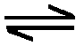 2NH_{3(g)}
If 80 kg of ammonia is produced from 60 kg of hydrogen, what is the percentage yield?
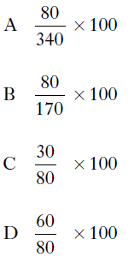

18. Two identical samples of copper(II) carbonate were added to an excess of 1 mol l^{–1}
hydrochloric acid and 1 mol l^{–1} sulphuric acid respectively.
Which of the following would have been different for the two reactions?
A The pH of the final solution
B The volume of gas produced
C The mass of water formed
D The mass of copper(II) carbonate dissolved

19. Which of the following is the best description of a feedstock?
A A consumer product such as a textile, plastic or detergent.
B A complex chemical that has been synthesised from small molecules.
C A mixture of chemicals formed by the cracking of the naphtha fraction from oil.
D A chemical from which other chemicals can be extracted or synthesised.

20. Which of the following compounds is a raw material in the chemical industry?
A Ammonia
B Calcium carbonate
C Hexane
D Nitric acid

21. The mean bond enthalpy of the N−H bond is equal to one third of the value of ΔH for
which change?
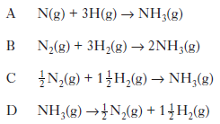
22. Ammonia is made by the Haber Process.
N_{2(g)} + 3H_{2(g)} 2NH_{3(g)}
The equilibrium position lies to the left. Which line in the table is correct?
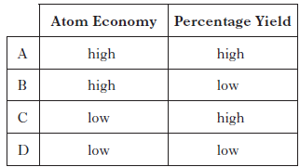

23. The flow chart summarises some industrial processes involving ethene.
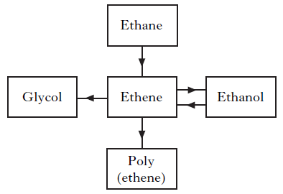

The feedstocks for ethene in these processes are
A ethane and glycol
B ethane and ethanol
C glycol and poly(ethene)
D glycol, poly(ethene) and ethanol.

24. Polylactic acid is used to make a biodegradable polymer. Polylactic acid can be manufactured by either a batch or a continuous process. What is meant by a batch process? (1)

25. Magnesium metal can be extracted from sea water.
An outline of the reactions involved is shown in the flow diagram.

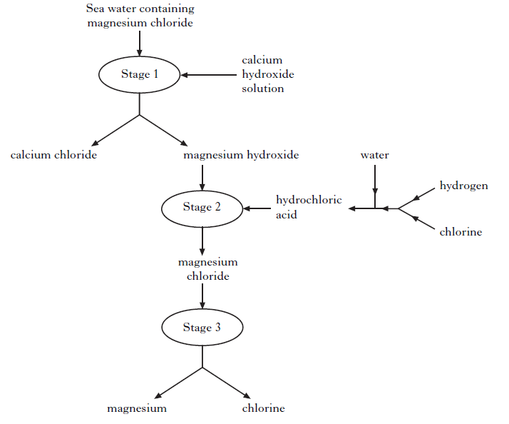

(a) Why can the magnesium hydroxide be easily separated from the calcium chloride at Stage 1? (1)

(b) Name the type of chemical reaction taking place at Stage 2. (1)

(c) Give two different features of this process that make it economical. (2)

26. Cerium metal is extracted from the mineral monazite.
The flow diagram for the extraction of cerium from the mineral is shown below.

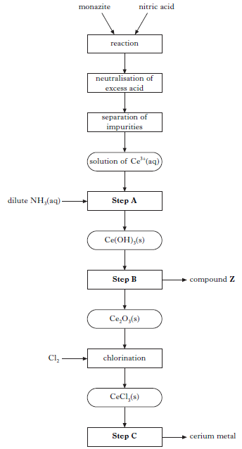

(a) Name the type of chemical reaction taking place in Step A. (1)

(b) In Step B, cerium hydroxide is heated to form cerium oxide, Ce₂O₃, and compound Z. Name compound Z. (1)

(c) In Step C, cerium metal is obtained by electrolysis. What feature of the electrolysis can be used to reduce the cost of cerium production? (1)

27. Chlorine gas can be produced by heating calcium hypochlorite, Ca(OCl)₂, in dilute
hydrochloric acid.
Ca(OCl)_{2(s)} + 2HCl_{(aq)} → Ca(OH)_{2(aq)} + 2Cl_{2(g)}
Calculate the mass of calcium hypochlorite that would be needed to produce 0·096 litres of chlorine gas. (Take the molar volume of chlorine gas to be 24 litres mol^{–1}.)
Show your working clearly. (2)

28. A student bubbled 240 cm³ of carbon dioxide into 400cm³ of 0.10 mol l^{–1} lithium hydroxide solution.
The equation for the reaction is:
2LiOH_{(aq)} + CO_{2(g)} → Li₂CO_{3(aq)} + H₂O_{(l)}
Calculate the number of moles of lithium hydroxide that would not have reacted.
(Take the molar volume of carbon dioxide to be 24 litres mol^{–1}.)
Show your working clearly. (2)

29. (a) In the lab, nitrogen dioxide gas can be prepared by heating copper(II) nitrate.
Cu(NO₃)_{2(s)} → CuO_{(s)} + 2NO_{2(g)} + ½ O_{2(g)}
Calculate the volume of nitrogen dioxide gas produced when 2.0g of copper(II) nitrate is completely decomposed on heating. (Take the molar volume of nitrogen dioxide to be 24 litres mol^{–1}.) Show your working clearly. (2)

(b) Nitrogen dioxide has a boiling point of 22 °C. Complete the diagram to show how nitrogen dioxide can be separated and collected. (1)

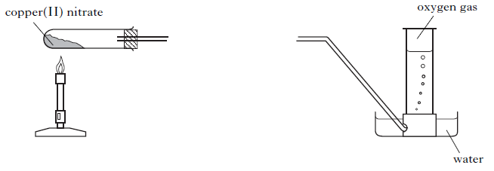

30. Sherbet contains a mixture of sodium hydrogencarbonate and tartaric acid. The
fizzing sensation in the mouth is due to the carbon dioxide produced in the
following reaction.
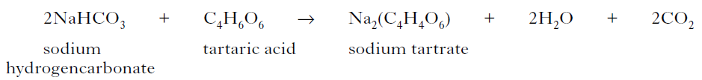
In an experiment, a student found that adding water to 20 sherbet sweets produced
105 cm³ of carbon dioxide. Assuming that sodium hydrogencarbonate is in excess, calculate the average mass of tartaric acid, in grams, in one sweet.
(Take the molar volume of carbon dioxide to be 24 litre mol^{–1}.)
Show your working clearly. (2)

31. The nutritional information states that 100 g of margarine contains 0.70 g of sodium. The sodium is present as sodium chloride (NaCl). Calculate the mass of sodium chloride, in g, present in every 100 g of margarine. (1)

32. Hydrogen fluoride gas is manufactured by reacting calcium fluoride with concentrated sulphuric acid.
CaF₂ + H₂SO₄ CaSO₄ + 2HF
What volume of hydrogen fluoride gas is produced when 1.0 kg of calcium fluoride reacts completely with concentrated sulphuric acid?
(Take the molar volume of hydrogen fluoride gas to be 24 litres mol–1.)
Show your working clearly. (2)

33. Methanamide, HCONH2, is widely used in industry to make nitrogen compounds.
It is also used as a solvent as it can dissolve ionic compounds.
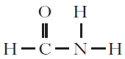

(a) Why is methanamide a suitable solvent for ionic compounds? (1)

(b) In industry, methanamide is produced by the reaction of an ester with ammonia.

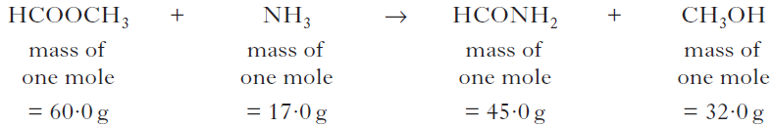

(i) Name the ester used in the industrial manufacture of methanamide. (1)

(ii) Calculate the atom economy for the production of methanamide. (1)

(c) In the lab, methanamide can be prepared by the reaction of methanoic acid
with ammonia.
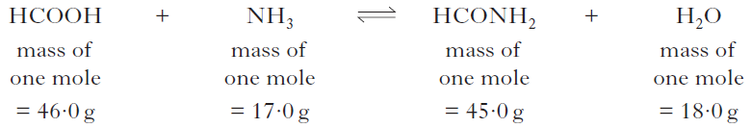

When 1·38 g of methanoic acid was reacted with excess ammonia, 0·945 g of methanamide was produced. Calculate the percentage yield of methanamide. Show your working clearly. (2)

34. Aspirin, a common pain-killer, can be made by the reaction of salicylic acid with
ethanoic anhydride.
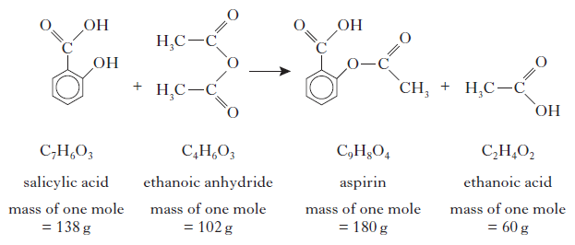
(a) Calculate the atom economy for the formation of aspirin using this method.
Show your working clearly. (2)

(b) In a laboratory preparation of aspirin, 5·02 g of salicylic acid produced 2·62 g
of aspirin. Calculate the percentage yield of aspirin. Show your working clearly. (2)

35. From the 1990s, ibuprofen has been synthesised by a three step process. The equation below shows the final step of the synthesis.

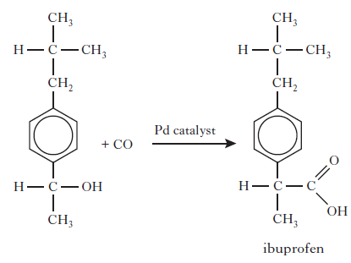
What is the atom economy of this step? (1)

36. One of the chemicals released in a bee sting is an ester that has the structure shown.
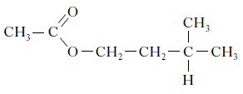
This ester can be produced by the reaction of 2-methylbutan-1-ol with ethanoic acid.
If there is a 65% yield, calculate the mass of ester produced, in grams, when 4.0 g of the alcohol reacts with a slight excess of the acid.
(Mass of one mole of the alcohol = 88 g; mass of one mole of the ester = 130 g)
Show your working clearly. (2)

37. Ammonia is produced in industry by the Haber Process.
N_{2(g)} + 3H_{2(g)} 2NH_{3(g)}
Under certain conditions, 500 kg of nitrogen reacts with excess hydrogen to produce
405 kg of ammonia. Calculate the percentage yield of ammonia under these conditions. Show your working clearly. (2)

38. Ethane-1,2-diol is produced in industry by reacting glycerol with hydrogen.
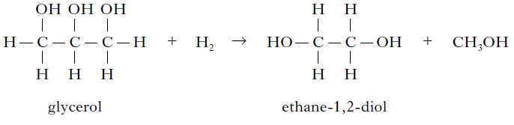
Excess hydrogen reacts with 27·6 kg of glycerol to produce 13·4 kg of ethane-1,2-diol.
Calculate the percentage yield of ethane-1,2-diol. Show your working clearly. (2)

49. Sulphur trioxide can be prepared in the laboratory by the reaction of sulphur dioxide
with oxygen.
2SO_{2(g)} + O_{2(g)} 2SO_{3(g)}
The sulphur dioxide and oxygen gases are dried by bubbling them through concentrated
sulphuric acid. The reaction mixture is passed over heated vanadium(V) oxide.
Sulphur trioxide has a melting point of 17 °C. It is collected as a white crystalline solid.

(a) Complete the diagram to show how the reactant gases are dried and the product is collected. (2)
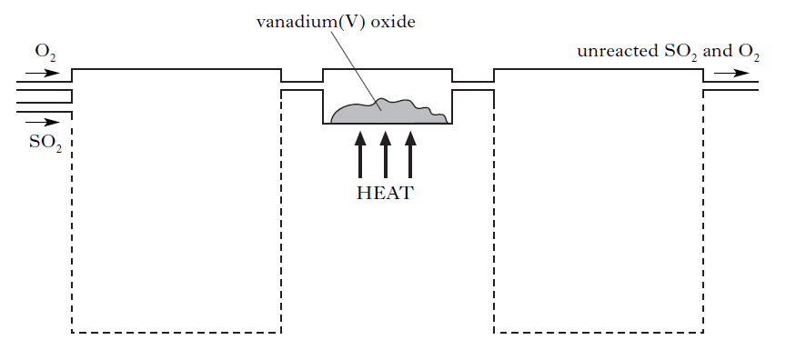
(b) Under certain conditions, 43·2 tonnes of sulphur trioxide are produced in the reaction of 51·2 tonnes of sulphur dioxide with excess oxygen. Calculate the percentage yield of sulphur trioxide. Show your working clearly. (2)

2.2 Equilibria
Summary

Equilibria
- If a reaction is in equilibrium its forward and reverse reactions have equal rate
- The concentrations of the products will be constant but not necessarily equal
- Changing conditions change the position of equilibrium:
Concentration:
- Addition of reactant or removal of a productthis shifts the equilibrium to the right
- Removal of a reactant or addition of a productthis shifts the equilibrium to the left
Temperature:
- Increase of temperature shifts to endothermic reaction (ΔH=+ve)
- Decrease of temperature shifts to exothermic reaction (ΔH=-ve)
Pressure:
- Increase pressure shifts to side with least moles of gas
- Decrease pressure shifts to side with most moles of gas
Catalyst:
- Has no effect on equilibrium position
- Equilibrium is reached faster

Equilibrium questions

1. A catalyst is used in the Haber Process.
N_{2(g)} + 3H_{2(g)} 2NH_{3(g)}
Which of the following best describes the action of the catalyst?
A Increases the rate of the forward reaction only
B Increases the rate of the reverse reaction only
C Increases the rate of both the forward and reverse reactions
D Changes the position of the equilibrium of the reaction

2. In which of the following systems will the equilibrium be unaffected by a change in
pressure?
A 2NO_{2(g)} N₂O_{4(g)}
B H_{2(g)} + I_{2(g)} 2HI_{(g)}
C N_{2(g)} + 3H_{2(g)} 2NH_{3(g)}
D 2NO_{(g)} + O_{2(g)} 2NO_{2(g)}

3. A few drops of concentrated sulphuric acid were added to a mixture of 0·1 mol of
methanol and 0·2 mol of ethanoic acid. Even after a considerable time, the reaction mixture was found to contain some of each reactant. Which of the following is the best explanation for the incomplete reaction?
A The temperature was too low.
B An equilibrium mixture was formed.
C Insufficient methanol was used.
D Insufficient ethanoic acid was used.

4. Which line in the table shows the effect of a catalyst on the reaction rates and position of equilibrium in a reversible reaction?
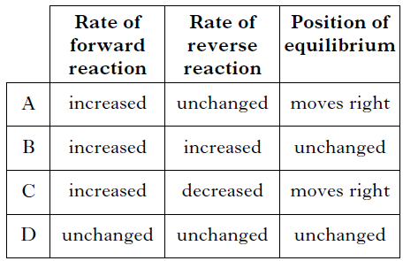

5. The following equilibrium exists in bromine water.
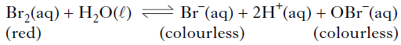
The red colour of bromine water would fade on adding a few drops of a concentrated
solution of
A HCl
B KBr
C AgNO³
D NaOBr.

6. A catalyst is added to a reaction at equilibrium. Which of the following does not apply?
A The rate of the forward reaction increases.
B The rate of the reverse reaction increases.
C The position of equilibrium remains unchanged.
D The position of equilibrium shifts to the right.

7. In which of the following reactions woulD an increase in pressure cause the equilibrium position to move to the left?
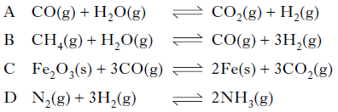

8. If ammonia is added to a solution containing copper(II) ions an equilibrium is set up.
Cu²⁺_{(aq)} + 2OH–_{(aq)} + 4NH_{3(aq)} Cu(NH₃)₄(OH)_{2(aq)}
(deep blue)
If acid is added to this equilibrium system
A the intensity of the deep blue colour will increase
B the equilibrium position will move to the right
C the concentration of Cu2+(aq) ions will increase
D the equilibrium position will not be affected.

9. Steam and carbon monoxide react to form an equilibrium mixture.
CO_{(g)} + H₂O_{(g)} H_{2(g)} + CO_{2(g)}
Which of the following graphs shows how the rates of the forward and reverse reactions
change when carbon monoxide and steam are mixed?
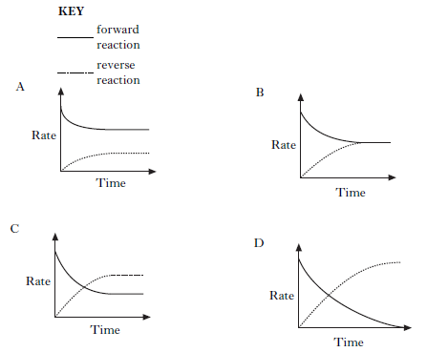

10. 2SO_{2(g)} + O2_{(g)} 2SO_{3(g)}
The equation represents a mixture at equilibrium. Which line in the table is true for the mixture after a further 2 hours of reaction?
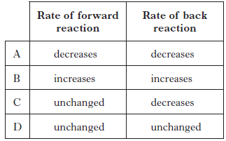

11. In which of the following would an increase in pressure result in the equilibrium position
being moved to the left?
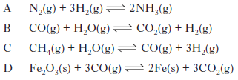

12. Nitrogen dioxide gas can be prepared in different ways. It is manufactured industrially as part of the Ostwald process. In the first stage of the process, nitrogen monoxide is produced by passing ammonia and oxygen over a platinum catalyst.
NH_{3(g)} + O_{2(g)} NO_{(g)} + H₂O_{(g)}

(a) Balance the above equation. (1)

(b) Platinum metal is a heterogeneous catalyst for this reaction. What is meant by a heterogeneous catalyst? (1)

(c) The nitrogen monoxide then combines with oxygen in an exothermic reaction to form nitrogen dioxide.
2NO_{(g)} + O_{2(g)} 2NO_{2(g)}
What happens to the yield of nitrogen dioxide gas if the reaction mixture is cooled? (1)

13. Atmospheric oxygen, O₂(g), dissolves in the Earth’s oceans forming dissolved oxygen, O_{2(aq)}, which is essential for aquatic life. An equilibrium is established.
O₂(g) + H₂O(l) O₂(aq) ΔH = –12·1 kJ mol–1

(a) (i) What is meant by a reaction at “equilibrium”?

(ii) What would happen to the concentration of dissolved oxygen if the temperature of the Earth’s oceans increased?

(b) A sample of oceanic water was found to contain 0·010 g of dissolved oxygen.
Calculate the number of moles of dissolved oxygen present in the sample. (1)

14. When cyclopropane gas is heated over a catalyst, it isomerises to form propene gas and an equilibrium is obtained.
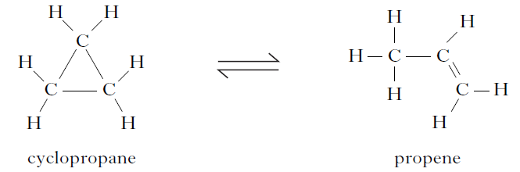

The graph shows the concentrations of cyclopropane and propene as equilibrium is established in the reaction.
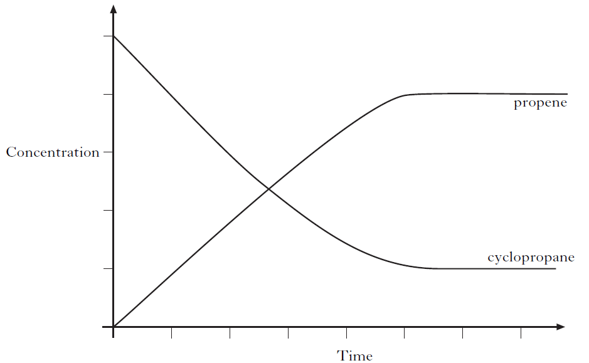
(a) Mark clearly on the graph the point at which equilibrium has just been reached. (1)

(b) Why does increasing the pressure have no effect on the position of this equilibrium? (1)
(c) The equilibrium can also be achieved by starting with propene.
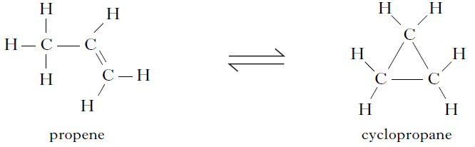
Using the initial concentrations shown, sketch a graph to show how the concentrations of propene and cyclopropane change as equilibrium is reached for the reverse reaction (1)
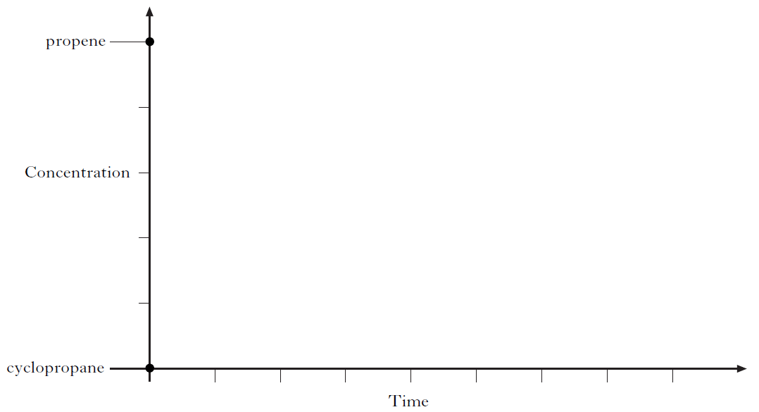

15. Tetrafluoroethene, C₂F₄, is produced in industry by a series of reactions. The final reaction in its manufacture is shown below.
2CHClF_{2(g)} C₂F_{4(g)} + 2HCl_{(g)}
The graph shows the variation in concentration of C₂F₄ formed as temperature is increased.
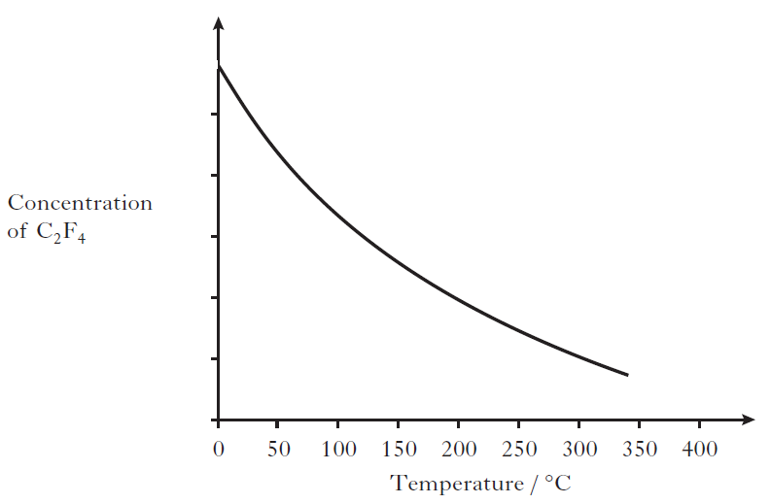
(a) What conclusion can be drawn about the enthalpy change for the formation of tetrafluoroethene? (1)

(b) Sketch a graph to show how the concentration of tetrafluoroethene formed would vary with increasing pressure. (1)
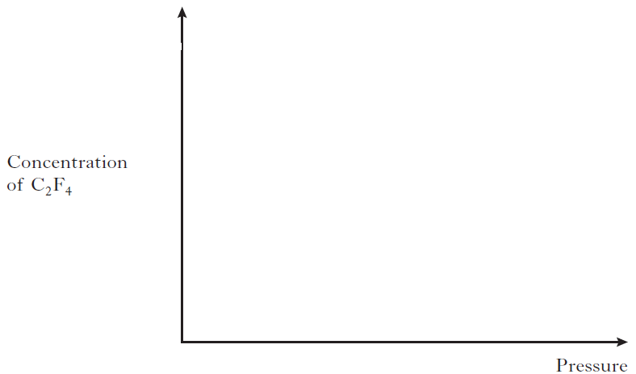

16. Ammonia is produced in industry by the Haber Process.
N_{2(g)} + 3H_{2(g)} 2NH_{3(g)}

(a) State whether the industrial manufacture of ammonia is likely to be a batch or a continuous process. (1)

(b) The graph shows how the percentage yield of ammonia changes with temperature at a pressure of 100 atmospheres.
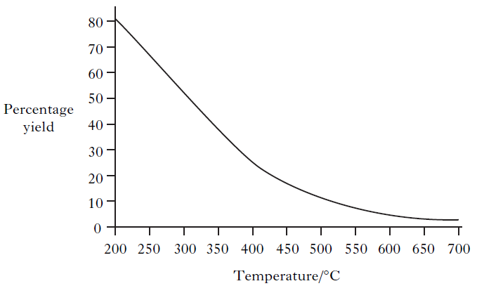
(i) A student correctly concludes from the graph that the production of ammonia is an exothermic process. What is the reasoning that leads to this conclusion? (1)

(ii) Explain clearly why the industrial manufacture of ammonia is carried out at a pressure greater than 100 atmospheres. (2)

17. Rivers and drains are carefully monitored to ensure that they remain uncontaminated by potentially harmful substances from nearby industries. Chromate ions, CrO42–, are particularly hazardous.
When chromate ions dissolve in water the following equilibrium is established.
2CrO4^{2–}_{(aq)} + 2H⁺(aq) Cr₂O₇ 2–_{(aq)} + H₂O_{(l)}
yellow orange
Explain fully the colour change that would be observed when solid sodium hydroxide is added to the solution. (2)

2.3 Chemical Energy
Summary
Definitions:
- Enthalpy of combustion-is the energy required for one mole of a substance to completely burn in oxygen
- Enthalpy of solution- the energy change when one mole of a substance is dissolved in water
- Enthalpy of neutralisation- the energy change when one mole of water is formed from a neutralisation reaction
- Bond enthalpy-the energy required to completely break all the bonds in one mole of a substance
- Enthalpy of sublimation- the energy required to turn one mole of solid atoms is turned into one mole of gaseous atoms
- Enthalpy of formation-the energy change when one mole a new substance is formed
Calculating the energies:
- The enthalpies of combustion, solution and neutralisation can be calculated experimentally.
- This could be done by measuring the mass of water/solutions, the temperature of water/solutions before and after and then using the equation:
$$E_{h}=cmΔT$$
Hess Law:
- Hess law states that no matter the route taken the energy change will always be the same.
- This means that by carefully examining a given equations you could work out energies of unknown reactions.
- You would do this by adding energies from various steps which give the same overall reaction.
Born Haber Cycle
- The overall enthalpy can be worked out by:
Bonds formed – bonds broken

Chemical Energy Questions

1. Which of the following represents an exothermic process?
A Cl_{2(g)} → 2Cl_{(g)}
B Na_{(s)} → Na_{(g)}
C Na_{(g)} → Na⁺_{(g)} + e–
D Na⁺_{(g)} + Cl–_{(g)} → Na⁺Cl–_{(s)}

2. Which of the following equations represents an enthalpy of combustion?
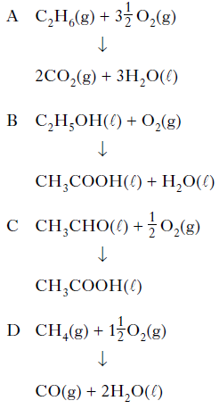

3. The enthalpy of combustion of methanol is –727 kJ mol^{–1}. What mass of methanol has to be burned to produce 72·7 kJ?
A 3·2 g
B 32·0 g
C 72·7 g
D 727·0 g

4. 5N₂O_{4(l)} + 4CH₃NHNH_{2(l)} → 4CO_{2(g)} + 12H₂O_{(l)} + 9N_{2(g)} ΔH = −5116 kJ
The energy released when 2 moles of each reactant are mixed and ignited is
A 2046 kJ
B 2558 kJ
C 4093 kJ
D 5116 kJ.

5. Aluminium reacts with oxygen to form aluminium oxide.
2Al_{(s)} + 1½O_{2(g)} → Al₂O_{3(s)} ΔH = −1670 kJ mol⁻¹
What is the enthalpy of combustion of aluminium in kJ mol⁻¹?
A −835
B −1113
C −1670
D +1670

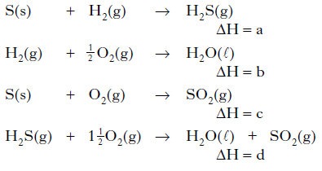
6.

What is the relationship between a, b, c and d?
A a = b + c – d
B a = d – b – c
C a = b – c – d
D a = d + c – b

7. Given the equations
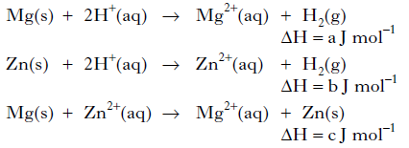
then, according to Hess’s Law
A c = a – b
B c = a + b
C c = b – a
D c = – b – a.

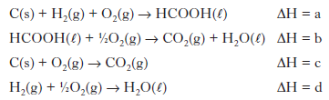
8.

What is the relationship between a, b, c and d?
A a = c + d − b
B a = b − c − d
C a = −b − c − d
D a = c + b + d

9. In the presence of bright light, hydrogen and chlorine react explosively. One step in the reaction is shown below.
H_{2(g)} + Cl_{(g)} → HCl_{(g)} + H_{(g)}
The enthalpy change for this step can be represented as
A (H-H bond enthalpy) + (Cl-Cl bond enthalpy)
B (H-H bond enthalpy) − (Cl-Cl bond enthalpy)
C (H-H bond enthalpy) + (H-Cl bond enthalpy)
D (H-H bond enthalpy) − (H-Cl bond enthalpy).

10. The energy changes taking place during chemical reactions have many everyday uses.
(a) Some portable cold packs make use of the temperature drop that takes place when the chemicals in the pack dissolve in water.
Name the type of reaction that results in a fall in temperature. (1)

(b) Flameless heaters are used by mountain climbers to heat food and drinks. The chemical reaction in a flameless heater releases 45 kJ of energy. If 200 g of water is heated using this heater, calculate the rise in temperature of the water, in °C. (1)

11. The compound diborane (B₂H₆) is used as a rocket fuel.
(a) It can be prepared as shown.
BF₃ + NaBH₄ → B₂H₆ + NaBF₄
Balance this equation. (1)

(b) The equation for the combustion of diborane is shown below.
B₂H_{6(g)} + 3O_{2(g)} → B₂O_{3(s)} + 3H₂O_{(l)}
Calculate the enthalpy of combustion of diborane (B₂H₆) in kJ mol⁻¹, using the following data. (2)
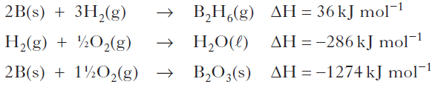

12. Hydrogen peroxide decomposes as shown:
H₂O_{2(aq)} → H₂O_{(l)} + ½ O_{2(g)}
The reaction can be catalysed by iron(III) nitrate solution.

(a) What type of catalyst is iron(III) nitrate solution in this reaction? (1)

(b) In order to calculate the enthalpy change for the decomposition of hydrogen peroxide, a student added iron(III) nitrate solution to hydrogen peroxide solution.
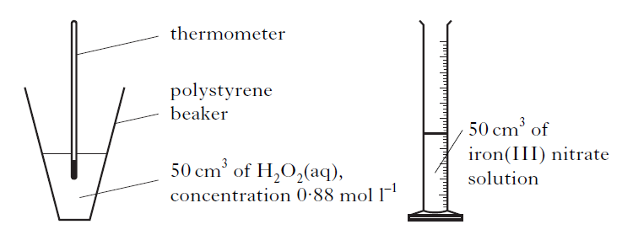
As a result of the reaction, the temperature of the solution in the polystyrene beaker
increased by 16 °C.
(i) What is the effect of the catalyst on the enthalpy change (ΔH) for the reaction? (1)

(ii) Use the experimental data to calculate the enthalpy change, in kJ mol–1, for the decomposition of hydrogen peroxide. Show your working clearly. (3)

13. A student used the simple laboratory apparatus shown to determine the enthalpy of combustion of methanol.
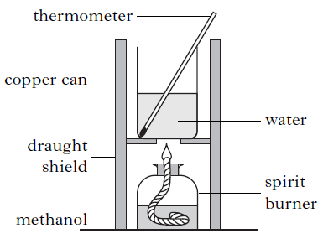
(a) (i) What measurements are needed to calculate the energy released by the burning methanol? (1)
(ii) The student found that burning 0.370 g of methanol produces 3.86 kJ of energy.
Use this result to calculate the enthalpy of combustion of methanol. (1)

(b) A more accurate value can be obtained using a bomb calorimeter.
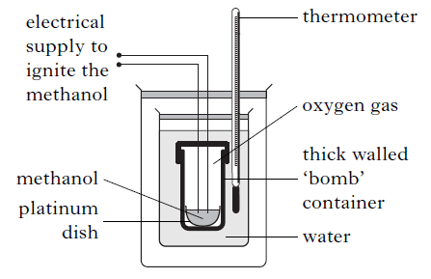
One reason for the more accurate value is that less heat is lost to the surroundings than in the simple laboratory method. Give one other reason for the value being more accurate in the bomb calorimeter method. (1)

14. Mobile phones are being developed that can be powered by methanol. Methanol can be made by a two-stage process.
In the first stage, methane is reacted with steam to produce a mixture of carbon monoxide and hydrogen.
CH_{4(g)} + H₂O_{(g)} CO_{(g)} + 3H_{2(g)}
Use the data below to calculate the enthalpy change, in kJ mol^{–1}, for the forward reaction.
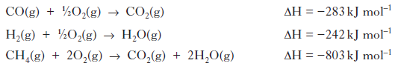
Show your working clearly. (2)

15. The enthalpies of combustion of some alcohols are shown in the table.
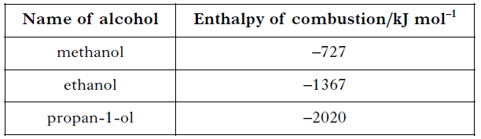

(a) Using this data, predict the enthalpy of combustion of butan-1-ol, in kJ mol–1. (1)

(b) A value for the enthalpy of combustion of butan-2-ol, C₄H₉OH, can be determined experimentally using the apparatus shown.

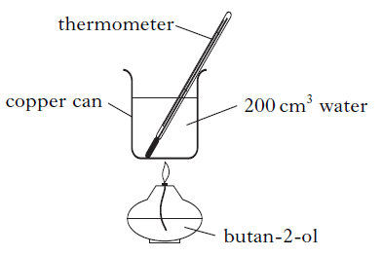
Mass of butan-2-ol burned = 1·0 g
Temperature rise of water = 40 °C
Use these results to calculate the enthalpy of combustion of butan-2-ol, in kJ mol^{–1}. (2)
(c) Enthalpy changes can also be calculated using Hess’s Law. The enthalpy of formation for pentan-1-ol is shown below.
5C_{(s)} + 6H_{2(g)} + ½ O_{2(g)} → C₅H₁₁OH_{(l)} ΔH = –354 kJ mol^{–1}
Using this value, and the enthalpies of combustion of carbon and hydrogen from the data booklet, calculate the enthalpy of combustion of pentan-1-ol, in kJ mol^{–1}. (2)

16. Different fuels are used for different purposes.
(a) Ethanol, C₂H₅OH, can be used as a fuel in some camping stoves.
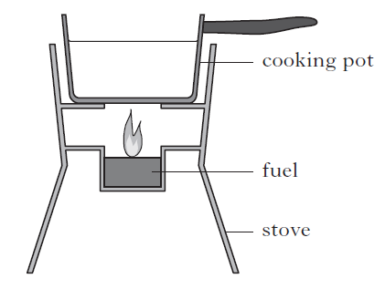
(i) The enthalpy of combustion of ethanol given in the data booklet is
−1367 kJ mol⁻¹. Using this value, calculate the mass of ethanol, in g, required to raise the temperature of 500 g of water from 18 °C to 100 °C. Show your working clearly. (3)

(ii) Suggest two reasons why less energy is obtained from burning ethanol in the camping stove than is predicted from its enthalpy of combustion. (2)

(b) Petrol is a fuel used in cars.
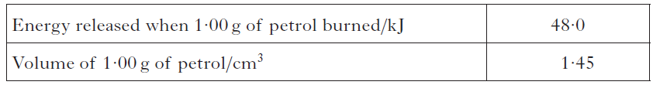
A car has a 50·0 litre petrol tank. Calculate the energy, in kJ, released by the complete combustion of one tank of petrol. (2)

17. Hydrogen has been named as a ‘fuel for the future’. In a recent article researchers
reported success in making hydrogen from glycerol:
C₃H₈O_{3(l)} → CO_{2(g)} + CH_{4(g)} + H_{2(g)}

(a) Balance this equation. (1)

(b) The enthalpy of formation of glycerol is the enthalpy change for the reaction:
3C_{(s)} + 4H_{2(g)} + 1½O_{2(g)} → C₃H₈O_{3(l)}
(graphite)

Calculate the enthalpy of formation of glycerol, in kJ mol^{–1}, using information from the data booklet and the following data.
C₃H₈O_{3(l)} + 3½O_{2(g)} → 3CO_{2(g)} + 4H₂O_{(l)} ΔH = –1654 kJ mol^{–1}
Show your working clearly. (2)

18. The equation for the enthalpy of formation of ethyne is:
2C_{(s)} + H_{2(g)} C₂H_{2(g)}
Use the enthalpies of combustion of carbon, hydrogen and ethyne given in the data booklet to calculate the enthalpy of formation of ethyne, in kJ mol–¹. Show your working clearly. (2)

19. Chloromethane can be produced by the reaction of methane with chlorine.
CH_{4(g)} + Cl_{2(g)} → CH₃Cl_{(g)} + HCl_{(g)}
Using bond enthalpies from the data booklet, calculate the enthalpy change, in
kJ mol⁻¹, for this reaction. (2)

20. The production of hydrogen chloride from hydrogen and chlorine is exothermic.
H_{2(g)} + Cl_{2(g)} → 2HCl_{(g)}
Using bond enthalpy values, calculate the enthalpy change, in kJ mol⁻¹, for this reaction. (2)

21. When in danger, bombardier beetles can fire a hot, toxic mixture of chemicals at the
attacker. This mixture contains quinone, C₆H₄O₂, a compound that is formed by the reaction of hydroquinone, C₆H₄(OH)₂, with hydrogen peroxide, H₂O₂. The reaction is catalysed by an enzyme called catalase.

(a) Most enzymes can catalyse only specific reactions, eg catalase cannot catalyse the hydrolysis of starch. Give a reason for this. (1)

(b) The equation for the overall reaction is:
C₆H₄(OH)_{2(aq)} + H₂O_{2(aq)} C₆H₄O_{2(aq)} + 2H₂O(l)
Use the following data to calculate the enthalpy change, in kJ mol^{–1}, for the above
reaction.
C₆H₄(OH)_{2(aq}) → C₆H₄O_{2(aq)} + H_{2(g)} ΔH = +177.4 kJ mol^{–1}
H_{2(g)} + O_{2(g)} → H₂O_{2(aq)} ΔH = –191.2 kJ mol^{–1}
H_{2(g)} + ½ O_{2(g)} → H₂O_{(g)} ΔH = –241.8 kJ mol^{–1}
H₂O_{(g)} → H₂O_{(l)} ΔH = –43.8 kJ mol^{–1}
Show your working clearly. (2)

22. (a) Methane is produced in the reaction of aluminium carbide with water.
Al₄C₃ + H₂O → Al(OH)₃ + CH₄
Balance the above equation. (1)

(b) Silane, silicon hydride, is formed in the reaction of silicon with hydrogen.
Si_{(s)} + 2H_{2(g)} → SiH_{4(g)}
silane

The enthalpy change for this reaction is called the enthalpy of formation of silane.
The combustion of silane gives silicon dioxide and water.
SiH_{4(g)} + 2O_{2(g)} → SiO_{2(s)} + 2H₂O_{(l)} ΔH = –1517 kJ mol^{–1}
The enthalpy of combustion of silicon is –911 kJ mol^{–1}.
Use this information and the enthalpy of combustion of hydrogen in the data booklet to calculate the enthalpy of formation of silane, in kJ mol–¹. Show your working clearly. (2)

23. (a) Hess’s Law can be verified using the reactions summarised below.
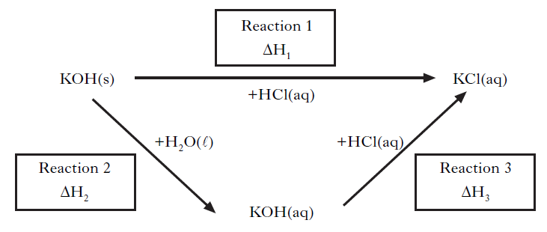
(i) Complete the list of measurements that would have to be carried out in order to determine the enthalpy change for Reaction 2. (1)

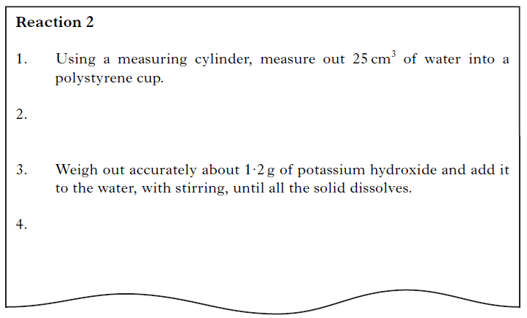
(ii) Why was the reaction carried out in a polystyrene cup? (1)

(iii) A student found that 1·08kJ of energy was released when 1·2 g of potassium hydroxide was dissolved completely in water. Calculate the enthalpy of solution of potassium hydroxide. (1)

(b) A student wrote the following incorrect statement.
The enthalpy of neutralisation for hydrochloric acid reacting with potassium hydroxide is less than that for sulphuric acid reacting with potassium hydroxide because fewer moles of water are formed as shown in these equations.
HCl + KOH → KCl + H₂O
H₂SO₄ + 2KOH → K₂SO₄ + 2H₂O
Explain the mistake in the student’s statement. (1)

2.4 Oxidising or Reducing Agents
Summary

Oxidation has three definitions:
- It is the loss of electrons
- The loss of hydrogen bonds
- The gain of oxygen bonds
Reduction is the opposite:
- It is the gain of electrons
- The gain of hydrogen bonds
- The loss of oxygen bonds
Oxidation and reduction must happen together-this is called REDOX
Oxidising and reducing agents:
- An oxidising agent is something which oxidises- the oxidising agent is reduced
- A reducing agent is something which reduces- the reducing agent is oxidised
How to tell if something will be oxidised or reduced:
- Metals will tend to loose electrons (oxidise)
- Non-metals will tend to gain electrons (reduce)
- The electrochemical series shows which elements are more likely to reduce- ‘the electrons flow from the high to the low’
Ion electron equations:
- Some ion electron equations are given on the electrochemical series
- The C-rule shows the direction the equations should be written
- YOU MUCT MAKE SURE THE ELECTRONS ARE BALANCED BEFORE COMBINING TO MAKE THE REDOX EQUATION
- If the ion electron equation isn’t given you should use the following rules
  - Balance the element
  - Balance the oxygen’s using H₂O
  - Balance the hydrogen’s by using H⁺
  - Balance the charge by using e⁻
Use of REDOX:
- REDOX is used to carry out lots of chemical reaction, most notably batteries.
- The voltages are found on the electrochemical series-the difference between two elements voltages is the amount of voltage these two elements could create

Reduction and Oxidation Questions

1. The iodate ion, IO₃–, can be converted to iodine.
Which is the correct ion-electron equation for the reaction?
A 2IO₃–_{(aq)} + 12H⁺_{(aq)} + 12e– 2I–_{(aq)} + 6H₂O_{(l)}
B IO₃–_{(aq)} + 6H⁺_{(aq)} + 7e– I–_{(aq)} + 3H₂O_{(l)}
C 2IO₃–_{(aq)} + 12H⁺_{(aq)} + 11e– I_{2(aq)} + 6H₂O_{(l)}
D 2IO₃–_{(aq)} + 12H⁺_{(aq)} + 10e– I_{2(aq)} + 6H₂O_{(l)}

2. Which of the following is a redox reaction?
A Mg + 2HCl MgCl₂ + H₂
B MgO + 2HCl MgCl₂ + H₂O
C MgCO₃ + 2HCl MgCl₂ + H₂O + CO₂
D Mg(OH)₂ + 2HCl MgCl₂ + 2H₂O

3. The ion-electron equations for a redox reaction are:
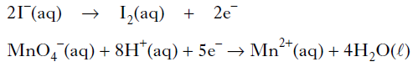
How many moles of iodide ions are oxidized by one mole of permanganate ions?
A 0.2
B 0.4
C 2
D 5

4. In which of the following reactions is the hydrogen ion acting as an oxidising agent?
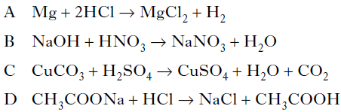

5. During a redox process in acid solution, iodate ions IO₃⁻_{(aq)} are converted into iodine I_{2(aq).}
IO₃⁻_{(aq)} → I_{2(aq)}
The numbers of H⁺_{(aq)} and H₂O_{(l)} required to balance the ion-electron equation for the
formation of 1 mol of I_{2(aq)} are, respectively
A 3 and 6
B 6 and 3
C 6 and 12
D 12 and 6.

6. In which of the following reactions is a positive ion reduced?
A Iodide iodine
B Nickel(II) nickel(III)
C Cobalt(III) cobalt(II)
D Sulphate sulphite

7. In which reaction is hydrogen gas acting as an oxidising agent?
A H₂ + CuO → H₂O + Cu
B H₂ + C₂H₄ → C₂H₆
C H₂ + Cl₂ → 2HCl
D H₂ + 2Na → 2NaH

8. Iodide ions can be oxidised using acidified potassium permanganate solution.
The equations are:
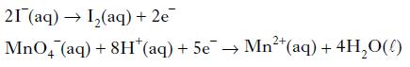
How many moles of iodide ions are oxidized by one mole of permanganate ions?
A 1.0
B 2.0
C 2.5
D 5.0

9. During a redox process in acid solution, iodate ions are converted into iodine.
2IO₃–_{(aq)} + 12H⁺_{(aq)} + xe– → I_{2(aq)} + 6H₂O_{(l)}
To balance the equation, what is the value of x?
A 2
B 6
C 10
D 12

10. The following reactions take place when nitric acid is added to zinc.
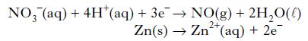
How many moles of NO₃– _{(aq)} are reduced by one mole of zinc?
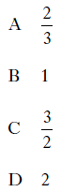

11. One of the reactions taking place within a carbon monoxide sensor is
2CO + 2H₂O → 2CO₂ + 4H⁺ + 4e⁻
This reaction is an example of
A reduction
B redox
C oxidation
D hydration.

12. The concentration of ethanol in a person’s breath can be determined by measuring the voltage produced in an electrochemical cell.
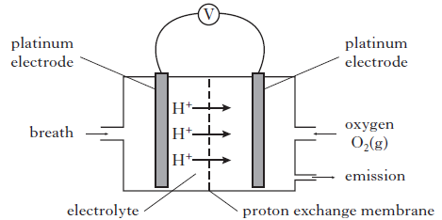
Different ethanol vapour concentrations produce different voltages as is shown in
the graph below.

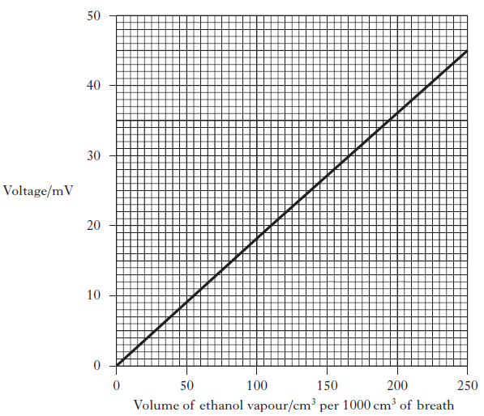

(a) Calculate the mass of ethanol, in g, in 1000 cm³ of breath when a voltage of 20 mV was recorded. (Take the molar volume of ethanol, C₂H₅OH, vapour to be
24 litres mol⁻¹.) Show your working clearly. (3)

(b) The ion-electron equations for the reduction and oxidation reactions occurring in the cell are shown below.
O₂ + 4H⁺ + 4e⁻ → 2H₂O
CH₃CH₂OH + H₂O → CH₃COOH + 4H⁺ + 4e⁻
Write the overall redox equation for the reaction taking place. (1)

13. Oxalic acid is found in rhubarb. The number of moles of oxalic acid in a carton of rhubarb juice can be found by titrating samples of the juice with a solution of potassium permanganate, a powerful oxidising agent.
The equation for the overall reaction is:
5(COOH)_{2(aq)} + 6H⁺_{(aq)} + 2MnO₄ –_{(aq)} → 2Mn²⁺ _{(aq)} + 10CO₂(aq) + 8H₂O_{(l)}

(a) Write the ion-electron equation for the reduction reaction. (1)

(b) Why is an indicator not required to detect the end-point of the titration? (1)

