Harris Academy S2 Electives
Information Booklet
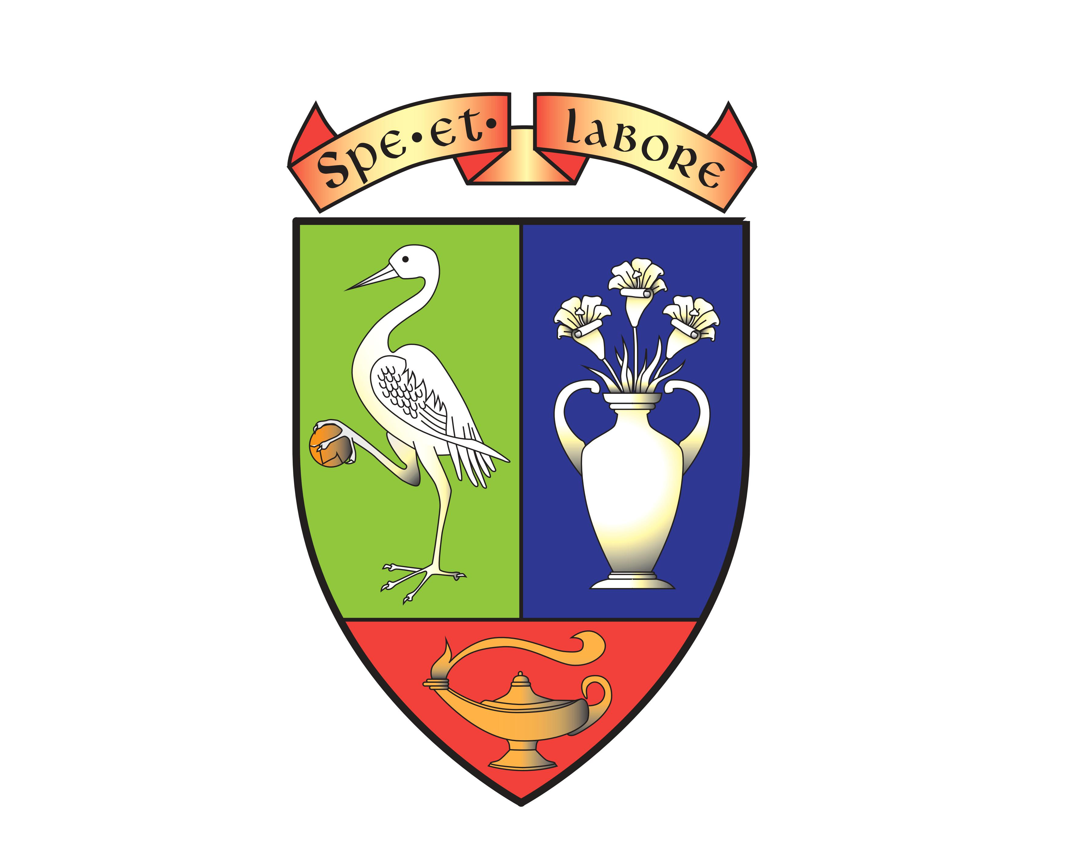

June 2024
https://forms.office.com/e/KbzkMsp6D2

Contents
Introduction
Courses in:

Art
• Anime Character Design

Business
• S2 Dragon’s Den

CDT
• S2 DIY Skills

Computing
• Computing Science

English
• Media

Geography
• Race Across the World

Home Economics
• Cake
• Fashion & Textile
• Foods of the World

Modern Languages
• Europe Through Festivals & Film

Nurture & Inclusion
• Peer Education

PE
• Skills Beyond Sport

RMPS
• Book Club

Introduction
Personalisation and choice in S2
All pupils follow a Broad General Education from S1-S3, building on the progress you made in primary school and preparing you for the Senior Phase from S4-S6 when you will specialise in national qualifications. As part of your S2 curriculum you will have the chance to personalise your curriculum by choosing an extra subject known as an ‘elective’. In S2 you will study the elective you have chosen for 1 period per week for half the academic year. You will have the opportunity to study two electives in S2. Most classes will be practical sets of 20.
In this booklet you will find descriptions of all these electives. Each one is designed to provide you with extra opportunities for achievement and to build your skills for learning, life, and work.
Please read this information carefully.
Please note that all courses are subject to limitations on uptake.
This booklet is also available from the school website.
Art

- Anime Character Development
Anime is best explained as being "a style of animation originating in Japan". It is increasingly popular worldwide, and over 300 million people streamed Anime in 2022.
Pupils follow the Design Process to create their own Anime character.
Research and Investigation is great fun and involves researching Studio Ghibli’s work – you will watch ‘My Neighbour Totoro’ which is a film that tells the story of a family that relocates to the countryside and discover a mysterious place of spirits, magic, and fabulous woodland creatures.
When developing ideas pupils draw a dual-coding mind map considering their character’s appearance and occupation. They will get plenty of time to experiment with facial expression, clothing, and accessories.
The final design is hand-drawn using fine line pen. The Art and Design Department has access to a fabulous ICT Suite where colour is added to this drawing using Photoshop.
Pupils also get the opportunity to consider an environment or background for their character and can develop this even further to create a cartoon strip.
Skills 4:0 is embedded in every lesson. Pupils get the chance to further develop their drawing and designing skills and experiment with media; graphite pencil, fine line pen, colour pencil and pens and ultimately, Photoshop. All these media are used in our BGE, National 4 and 5 courses giving Anime pupils a solid foundation for future courses in Art and Design.

Business

- Dragon’s Den

Entrepreneurs set up businesses for a variety of reasons. Ultimately however, successful businesses survive by meeting customer needs. Within this elective, you will be creating products in groups and gaining an insight into what entrepreneurs need to consider when setting up a business from scratch. These business ideas will then be pitched to the class and a winner will be chosen by the other groups.

CDT

- S2 DIY Skills

We will focus on basic DIY skills that may come in useful in later life. This will be things like wiring a plug, fixing plasterboard, filling gaps in material and using basic power tools. Building on your basic workshop knowledge throughout the year we will use a variety of techniques and materials.

Computing

- Computing Science
In this elective you will look at and evaluate existing games and explore game design techniques. You will design and create at least one game from start to finish using GameMaker Studio using sprites and objects.

English

- Media
How does Media influence us?

The Media class will explore ways in which media influences our daily life and the methods media creators use to impact on the choices we make. You will learn about representation and stereotypes; how characters are represented and how young people are stereotyped. You will have the opportunity to put your learning into practice by creating your own media product.

Geography

- Race Across the World
Do you love travel, tourism and Geography? This class will look at a journey across the globe looking at the landscape, people and tourist attractions along the way. We will plan holidays and look in more detail at cultures and global issues affecting places around the world.

Home Economics

- Cake
In this fun elective you will bake a variety of different cake types and then decorate these using a range of cake decorating tools and decorative techniques. If you have a passion for baking and cake decorating, then this elective is perfect.

- Fashion and Textile Technology
During this elective you will become confident in the use a range of sewing tools and equipment whilst creating some fun textile projects. These range from a mini tote bag, bookmark, festive decorations and so much more. If you have an interest in learning some new textile skills or you are already a keen crafter then you will love this elective.

- Foods of the World
This elective will take you on an exciting Worldwide ‘tour’ whilst giving you a great opportunity to further develop your practical food skills. Each week you will prepare a dish from a different country, you will learn about the origins of the dishes and interesting facts about the ingredients you are using. If you enjoy cooking and are keen to expand your knowledge and skills, then this is the elective for you!

Modern Languages

- Europe through Festivals and Films
In this elective will learn about some of the fun and amazing festivals which happen around Europe. You will also have the chance to watch and evaluate films. You could even design and run your own Scottish festival taking aspects from all you learn.

Nurture & Inclusion

- Peer Education
This is a unique opportunity for selected S2 pupils to work with primary 7 pupils who will be joining us at Harris in August 2024. Initially, you will take part in a Training Programme that will help to prepare you for a series of visits to primary schools where you will be leading small groups. Ideally, we are looking for young people who can become role-models and help to inspire our future S1s. Pupils who successfully complete this elective will receive a Dynamic Youth ((Bronze) Award detailing your new skills and experiences. Please note that this elective will last all year. This is because you will spend the first half of the year undergoing the training sessions and then the second half going out to primary schools. Spaces are limited so please speak to Mrs Smith if you would like more information.

PE

- Skills Beyond Sport
This will allow pupils to discover other areas of sport to develop skills beyond the pitch. You will apply your swimming skills in a block of rookie Lifeguarding to improve your ability to help someone in difficulty in the water. You will have the chance to develop bike skills including basic bike care. You will discover new sports some you may not have heard of. This is an exciting elective that will allow you to see many aspects of sport and life skills that can be developed in a sporting environment.

RMPS

- Book Club
In this elective we will have the chance to discuss some of the books that we enjoy reading, and why we enjoy them. We will select a book to read as a class and then discuss the key themes of the book and at the end of the book we will have an opportunity to do some writing of our own which builds on those key themes. By the end of the elective, we will also have a selection of book reviews written by the class that we will display so that others can read the books we love too!

