Our Values  Compassion  Respect  Ambition  Integrity  Generosity  Openness  Wisdom  Loyalty | 11th November 2019  Dear Parents/Carers,    Our Vision  After consultation with pupils, parents, carers, staff and partners we launched our new vision at the assembly on the first day back after the October holidays. It is a simpler, easier to remember vision than our previous one which will hopefully make it more relevant and become part of everyday life for our whole school community.  Thank you to those who responded to our survey asking for views about our vision. We hope that we have captured most of what people feel we should be doing as a school.  You will find the vision at the bottom of every newsletter from now on.  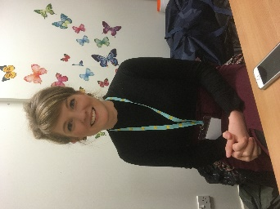  Place2Be  We were very excited last week when Laura Dickson our Place2Be School Project Manager started. Place2Be is a Counselling service which has worked in schools in other areas of the country and is now starting in Dundee. Once we get the project up and running Laura and her team will provide support to children, staff and parents. If you see Laura around the school please say hello and make her feel welcome.  In Service Days  Just a quick reminder that the school will be closed to children on Thursday and Friday (14th & 15th) of this week as they are In Service Days. There a whole range of activities planned for staff including music, making children’s learning visible, outdoor learning, and tracking children’s progress.  Easyfundraising    Recently one of our supporters raised £12.50 for us when he booked a holiday. Not all donations are this size but each one is valued. If you are buying Christmas presents online (or booking a holiday) please login to easyfundrasing.org, choose Craigowl as your charity and then search for your online shopping site. We will receive a donation from the retailer, but it won’t cost you a penny more!  General Election  As you will be aware the Prime Minister has called a General Election for Thursday 12th December. The school will be used as a polling station and so again will be closed to children.
Our Vision
Craigowl Primary School will welcome, value and nurture everyone. We will play an active part in the community and inspire our learners to dream, believe and achieve.

