22nd August 2019
Our Values  Compassion  Respect  Ambition  Integrity  Generosity  Openness  Wisdom  Loyalty | 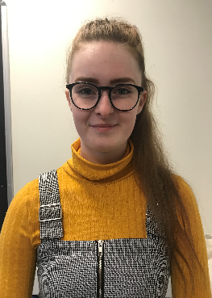  Dear Parents/Carers,  Last week we have welcomed new members to the Craigowl family. Miss Hannah Taylor has joined the nursery team as an Early Years Educator. She is already getting to know some of the youngsters and has been welcoming the new children joining the Red Group.  8 eager young learners joined us to start P1 along with the 37 children who had moved up to P1 from our Nursery Class. We also welcomed new pupils into P2, P3, P4, P5 and P6 and hope that they will all soon make friends and feel at home with us.  The nursery class has been welcoming new children in and it is great to see them getting to know their way around the nursery and the outdoor area.  Last Monday we were able to catch up with Mrs Petrie and Miss Gilchrist who returned from maternity leave. It already feels as if they have never been away as they have picked up where they left off. Mrs Evetts was also due to return to work last week but unfortunately she had an accident which has resulted in surgery and a stay in hospital. She will now need a number of weeks to recover and we all wish her well for a speedy recovery.  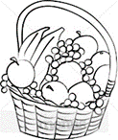  Tuck Shop  Our Healthy Tuckshop is up and running again and a selection of fruits, cheese, yoghurt, water and milk are on sale daily. The tuckshop opens over the morning interval time and prices range from 20p – 30p.  Labelling  Please can I remind you about labelling everything your child brings to school. Packed lunch boxes, Tupperware containers, water bottles and school uniform should all have your child’s name on them. It is amazing how much stuff we find lying around every day that we cannot return to the owner as it has no name on it. Last week we had a packed lunch eaten by the wrong person as they picked up an identical box. It would be really helpful if you could put a sticker or some sort of identifying mark on the outside of your child’s packed lunch box so your child can recognise their own box.    Save By The Bell  Every Monday morning Save by The Bell, our junior savings scheme, have a collection point in school. If you would like your child to start saving with them they will be happy to give you an application form and more details.
Our Vision
Craigowl Primary School will serve, and be a part of, the local and wider community. We will provide a welcoming and nurturing environment in which diversity is valued, and equality and inclusion promoted. Working in partnership, we will provide opportunities which will prepare our children for the future.

