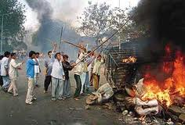

The United Nations has gradually expanded human rights laws to encompass specific standards for women, children, disabled people, minorities, migrant workers and other vulnerable groups. They now possess rights that protect them from discriminatory practices that had long been common in any societies.

Rights have been extended through ground-breaking General Assembly decisions that have gradually established their universality, indivisibility and interrelatedness with development and democracy.

http://www.un.org/rights/morerights.htm

[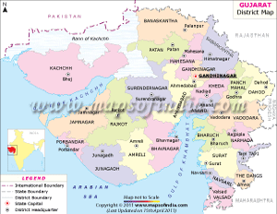](http://www.mapsofindia.com/maps/gujarat/gujarat-district.htm)

On February 27th 2012, in the Indian city of Godra, Gujarat, a Muslim crowd attacked a train filled with Hindu activists setting on fire 2 cars and killing 27 people. The event triggered a violent spiral of religious revenge and four days later two thousand Muslims were killed. Their homes, mosques and trades destroyed and hundreds of women raped and mutilated before the members of their families.

Later investigations revealed that the attacks had been planned and done with mutual approval and collaboration of the local authorities.

The UN Declaration of Human Rights states Right 3 is ‘everyone has right to life and to live in freedom and safety’. – www.bbcnews.co.uk

**Emma Young** 

Menzieshill High School

**United Times**

Wednesday 21 September 2012