poli | polite |  | compréhensif | understanding
charmant | charming |  | sportif | sporty
mort | dead |  | créatif | creative
méchant | nasty, horrible
bruyant | noisy
ouvert | open
bavard | talkative |  | paresseux | lazy
intelligent | intelligent |  | ennuyeux | boring
amusant | funny |  | heureux | happy
marrant | funny |  | sérieux | serious
barbant | boring
intéressant | interesting
séparé | separated |  | travailleur | hard working
divorcé | divorced |  | plein de vie | full of life
marié | married |  | fou | mad
animé | lively |  | gentil | nice
équilibré | well balanced |  | rigolo | funny
 |  |  | casse-pieds | annoying
triste | sad
calme | calm
sage | well behaved
aimable | friendly |  | 
sévère | strict
timide | shy
vieille | old (feminine)
moche | ugly
sympathique | nice |  | 
formidable | fantastic
jeune | young
je m’entends bien avec | I get on well with
je me dispute avec | I argue with
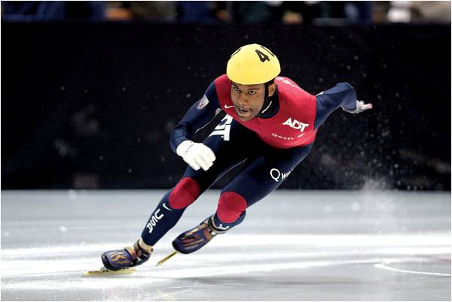
A thorough knowledge of vocabulary is essential for making progress in French. We recommend that pupils spend a little time (5-10mins) every evening memorizing vocabulary.
Could you please sign and date this vocabulary sheet to say you are satisfied that your son/daughter has learnt these words to your satisfaction. Many thanks.

__________________________________________________ _____________________________

