MA FAMILLE | My Family |  | avoir | to have
 |  |  | j’ai | I have
le frère | the brother |  | tu as | you have
la soeur | the sister |  | il a | he has
le père | the father |  | elle a | she has
la mère | the mother |  | As-tu...? | Do you have....?
les parents | the parents
le grand-père | the grandfather |  | être | to be
la grand-mère | the grandmother |  | je suis | I am
 |  |  | tu es | you are
la tante | the auntie |  | il est |   he is
l’oncle | the uncle |  | elle est | she is
la fille | the girl, daughter |  | s’appelle | is called
le fils | the son |  | de | of
le garçon | the boy
le beau-père | the step dad |  | PHYSICAL BUILD
la belle-mère | the step mother |  | assez | quite
le demi-frère | the step brother |  | très | very
la demi-soeur | the step sister
 |  |  | petit (e) | small
le frère jumeau | the twin brother |  | de taille moyenne | medium height
la soeur jumelle | the twin sister |  | grand (e) | big, tall
 |  |  | gros (se) | fat
la femme | the wife |  | mince | slim
le mari | the husband
 |  |  | il porte | he wears
les copains | the friends |  | des lunettes | glasses
les amis | the friends |  | une barbe | a beard
HAIR AND EYES
les yeux bleus | blue eyes |  | les cheveux longs | long hair
les yeux verts | green eyes |  | les cheveux mi-longs | medium length hair
les yeux bruns | brown eyes |  | les cheveux frisés | curly hair
les yeux marron | brown eyes |  | les cheveux raides | straight hair
les yeux noisette | hazel eyes |  | les cheveux bouclés | curly hair
 |  |  | les cheveux courts | short hair
les cheveux blonds | blond hair |  |  | 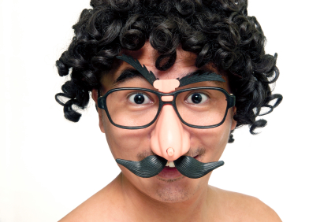
les cheveux noirs | black hair
les cheveux gris | grey hair
les cheveux châtains | brown hair
les cheveux bruns | brown hair
les cheveux roux | red hair

A thorough knowledge of vocabulary is essential for making progress in French. We recommend that pupils spend a little time (5-10mins) every evening memorizing vocabulary.
Could you please sign and date this vocabulary sheet to say you are satisfied that your son/daughter has learnt these words to your satisfaction. Many thanks.

__________________________________________________ _____________________________

