A VERBS | A VERBS |  | C SHOPS | C SHOPS
il porte | he is wearing |  | 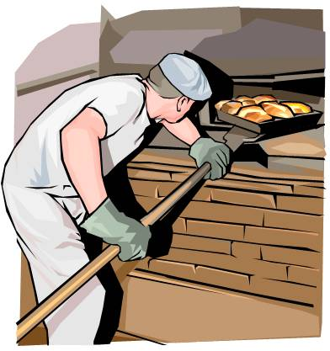  la boulangerie | the bakers
elle porte | she is wearing |  | le marché | the market
 |  |  | la boucherie | 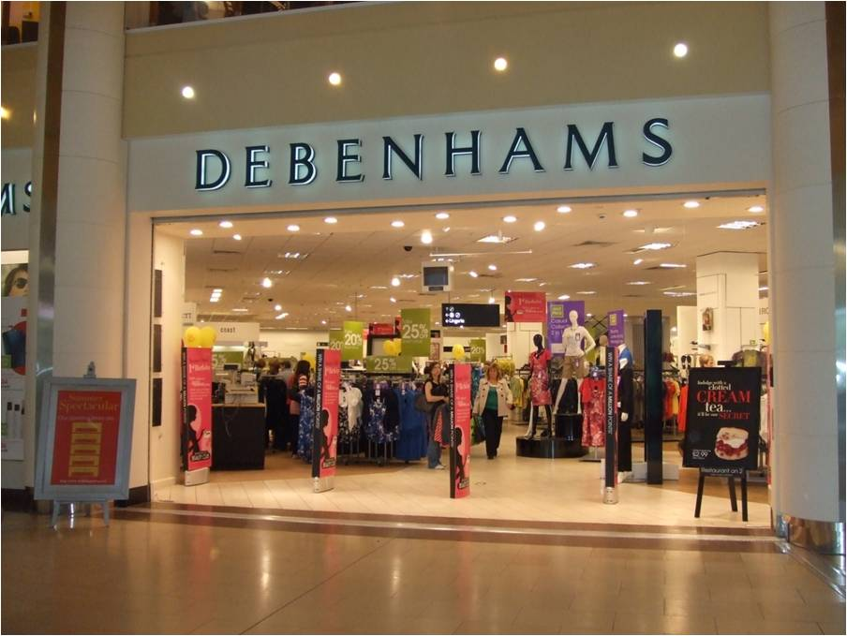  the butchers
 |  |  | la pharmacie | the chemists
B CLOTHES | B. CLOTHES |  | la pâtisserie | the cake shop
un polo | 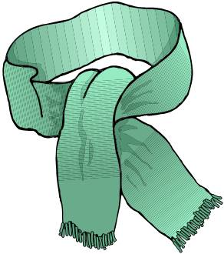  a polo shirt |  | la poste | the post office
un collant | tights |  | le supermarché | the supermarket
des baskets | trainers |  | le grand magasin | the department store
des tennis | tennis shoes |  | la librairie | the book shop
des chaussettes | socks |  | le salon de coiffure | the hairdressers
des chaussures | 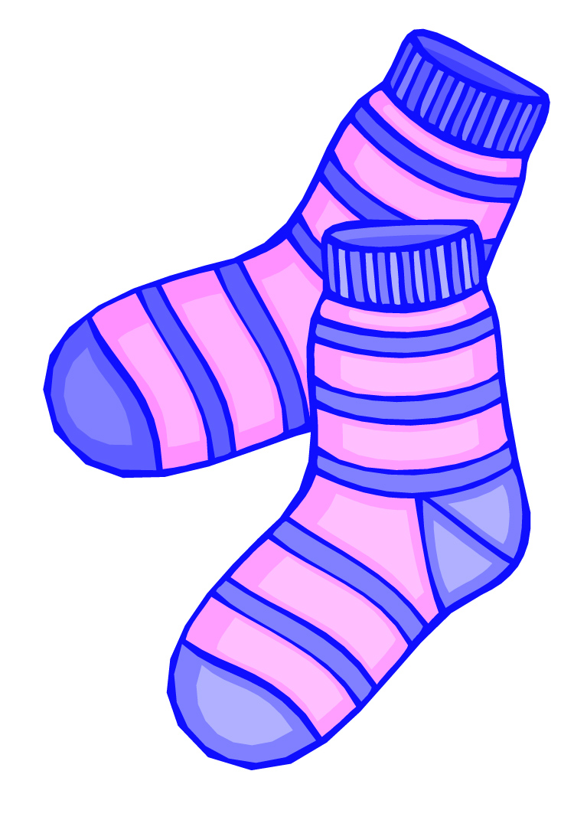  shoes |  | le centre commercial | the shopping centre
une chemise | a shirt |  | le magasin de chaussures | the shoe shop
une cravate | a tie |  | le magasin de sport | the sports shop
une robe | a dress |  | le magasin de mode | the fashion store
un jean | jeans |  | le grand magasin | the department store
une jupe | a skirt |  | le fleuriste | the flower shop
un sweat | a sweatshirt |  | la confiserie | the sweet shop
un pull | a jumper
un pantalon | trousers
un tee-shirt | a t-shirt
des lunettes de soleil | 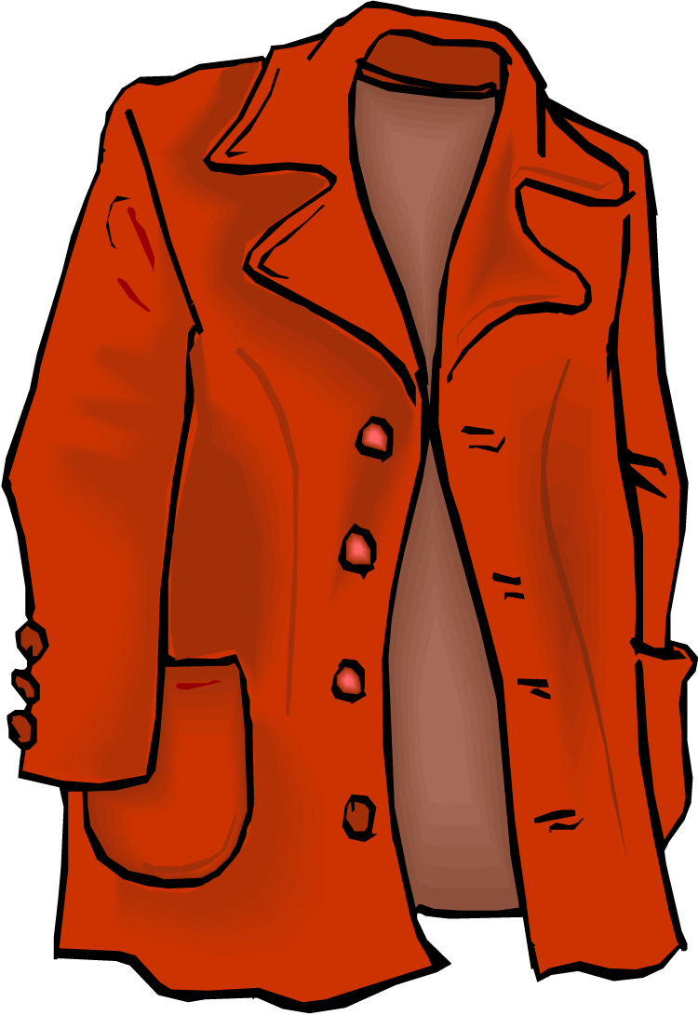  sunglasses |  | D. DEPARTMENT STORE | D. DEPARTMENT STORE
une écharpe | a scarf |  | au sous-sol | on the basement
des gants | gloves |  | au rez-de-chaussée | on the ground floor
une veste | a jacket |  | au premier étage | on the first floor
un manteau | a coat |  | au deuxième étage | on the second floor
un blouson | jacket |  | au troisième étage | on the third floor
un maillot | a football shirt
un maillot de bain | a swimming costume
 |  |  | E. DEPARTMENTS | E. DEPARTMENTS
 |  |  | jouets | toy department
 |  |  | parfumerie | perfume department
 |  |  | sport | sports department
 |  |  | femme | womens clothes
 |  |  | homme | mens clothes
 |  |  | l’alimentation | food department
 |  |  | chaussures | shoe department
 |  |  | le rayon | the isle
 |  |  | cadeaux | gifts
