SCHOOL TYPES |  |  | QUESTIONS
une école maternelle | a nursery school |  | à quelle heure | at what time?
une école primaire | a primary school |  | combien de....? | how many?
le collège | secondary school |  | quelle | what
le lycée | secondary school |  | quelle sorte..? | what kind of...?
TIMETABLE |  |  | OTHERS
un emploi de temps | a timetable |  | la rentrée | return to school (after hols)
un cours | a lesson |  | il faut | it is necessary
une leçon | a lesson |  | il y a | there is, there are
la recreation (la récré) | the interval |  | les devoirs | the homework
la pause de midi | the lunch break |  | le voyage scolaire | the school trip
l’école est fini | school is finished |  | un échange | an exchange
EXAMS |  |  | PLACES IN SCHOOL
passer un examen | to sit an exam |  | la cantine | canteen
une note | a mark, grade |  | la salle de classe | classroom
une bonne note | a good mark |  | le gymnase | the gym hall, sports hall
une mauvaise note | a bad mark
le bulletin | the report card
TIME PHRASES |  |  | PEOPLE
le matin | in the morning |  | le directeur | headteacher
l’après-midi | the afternoon |  | la secrétaire | secretary
commencer | to start |  | le professeur | the teacher
durer | to last |  | les élèves | the pupils
plus tard | later
plus tôt | earlier |  |  | 
 |  |  | 
les matières | the subjects
ma matière préférée | my favourite subject
est | is
sont | are
apprendre | to learn
j’apprends | I learn |  |  | 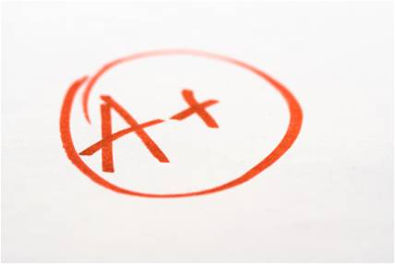
interdit | forbidden, not allowed
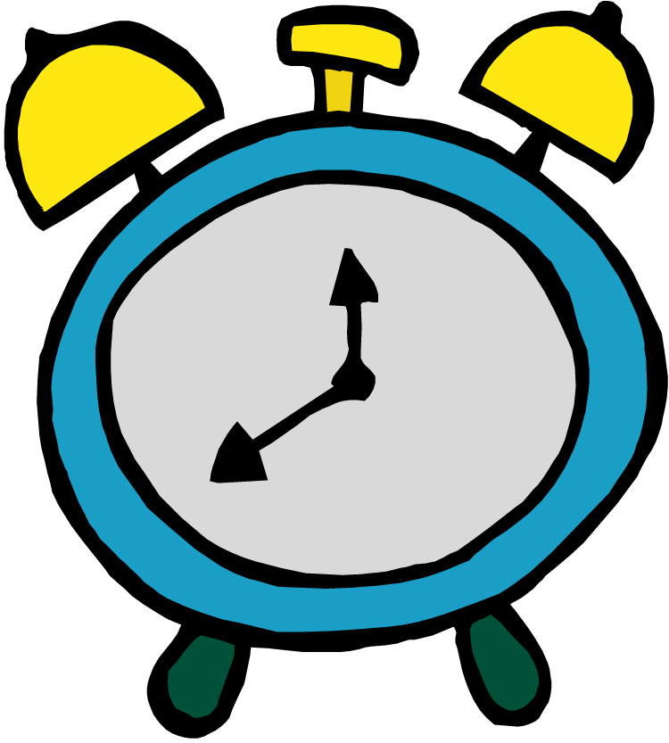

A thorough knowledge of vocabulary is essential for making progress in French. We recommend that pupils spend a little time (5-10mins) every evening memorizing vocabulary.
Could you please sign and date this vocabulary sheet to say you are satisfied that your son/daughter has learnt these words to your satisfaction. Many thanks.

__________________________________________________ _____________________________

