A. SUBJECTS | A. SUBJECTS |  | B. OPINIONS | B. OPINIONS
les matières | the subjects |  | fort en | good at
la biologie |   biology |  | faible en | weak at, poor at
la physique | physics |  | difficile | difficult
la chimie | chemistry |  | facile | easy
les sciences | sciences |  | ennuyeux |   boring
le dessin | art |  | barbant | boring
la géographie | geography |  | utile | useful
l’EPS | PE |  | inutile | useless
l’éducation physique | physical education |  | super | super
l’histoire | history |  | intéressant | interesting
l’informatique | computing / ICT |  | nul | rubbish
les maths | maths |  | affreux | awful
l’anglais | english |  | bête | stupid
l’espagnol | spanish |  | fatigant | tiring
le français | french |  | sévère | strict
l’allemand | german |  | marrant | funny
les langues modernes | modern languages |  | amusant | funny
les langues étrangères | foreign languages |  | rigolo | funny
la musique | music |  | passionnant | 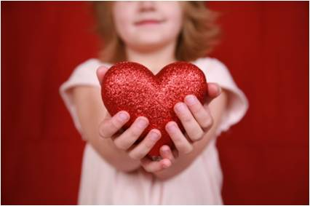  exciting
la technologie | Technical |  | génial | great
l’EMT | Technical |  | chouette | great
les travaux manuels | Technical |  | animé | lively
les arts dramatique | drama |  | sympa | nice
la réligion | RE |  | pas cher | cheap
 |  |  | calme | peaceful, quiet
 |  |  | tranquille | peaceful, quiet
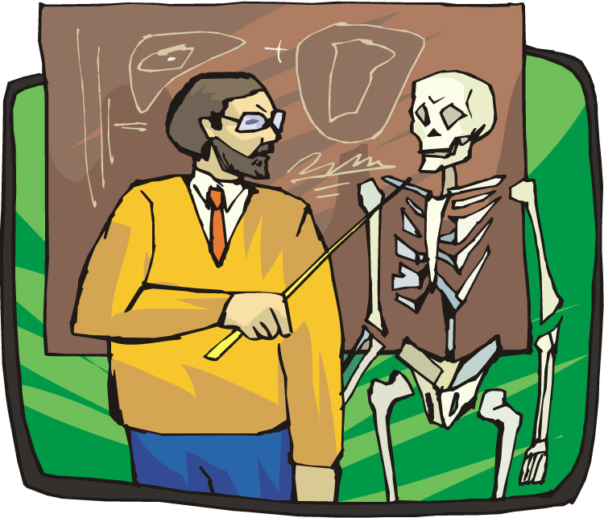 |  |  | ma matière préférée | my favourite subject
 | 
 |  |  | j’adore | I love
 |  |  | j’aime | I like
 |  |  | je n’aime pas | I don’t like
 |  |  | je déteste | I hate
 |  |  | j’ai horreur de | I hate

A thorough knowledge of vocabulary is essential for making progress in French. We recommend that pupils spend a little time (5-10mins) every evening memorizing vocabulary.
Could you please sign and date this vocabulary sheet to say you are satisfied that your son/daughter has learnt these words to your satisfaction. Many thanks.

__________________________________________________ _____________________________

