A START WITH | A START WITH |  | C OPINIONS | C OPINIONS
je travaille | I work |  | bien payé | well paid
dans | in |  | mal payé | badly paid
sur | on |  | fatigant | tiring
 |  |  | intéressant | interesting
 |  |  | 
B. PLACES OF WORK | B. PLACE OF WORK
un hôpital | 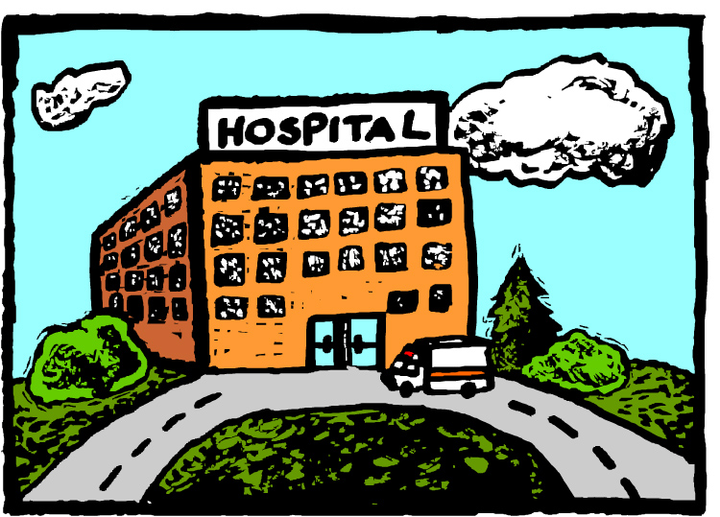  a hospital |  | facile | easy
un bureau | an office |  | difficile | difficult
un collège | a school |  | ennuyeux | boring
un lycée | a school |  | barbant | boring
un chantier | a building site
 |  |  | super | super
une usine | a factory |  | nul | rubbish
une boulangerie |   a bakery |  | génial | great
une boucherie | a butcher |  | chouette | great
une ferme | a farm
une banque | a bank |  | marrant |   funny
 |  |  | rigolo | funny
un magasin | a shop |  | amusant | funny
une bibliothèque | a library
une station-service | a petrol station |  | animé | lively
un salon de coiffure | a hairdressing salon |  | plein de vie | full of life
en ville | in town |  | calme | calm, quiet
 |  |  | tranquille | quiet, peaceful
chez moi | at my house
en plein air | outside |  | agréable | pleasant
dehors | outside |  | pas mal | not bad
 |  |  | dur | hard
 |  |  | affreux | awful
 |  |  | passionnant | exciting
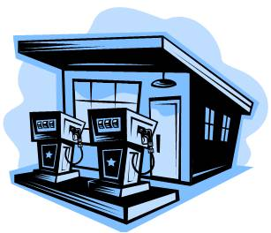 | 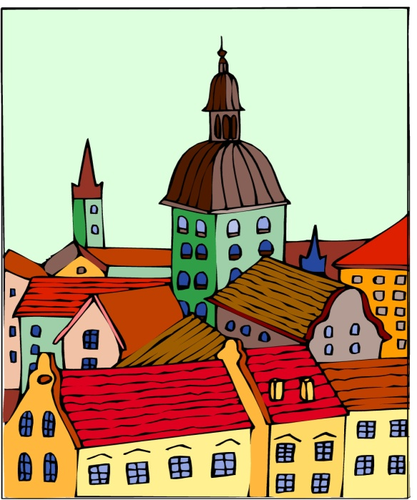

A thorough knowledge of vocabulary is essential for making progress in French. We recommend that pupils spend a little time (5-10mins) every evening memorizing vocabulary.
Could you please sign and date this vocabulary sheet to say you are satisfied that your son/daughter has learnt these words to your satisfaction. Many thanks.

__________________________________________________ _____________________________

