A VERBS | A VERBS |  | C QUESTIONS | C QUESTIONS
devenir | to become |  | À quelle heure..? | at what time..?
aimer | to like |  | combien de..? | how much, many..?
durer | to last |  | comment .. ? | how .. ?
être | to be
gagner | to earn |  | combien de temps? | how long?
travailler | to work |  | combien d’heures? | how many hours?
penser | to think |  | combien d’argent? | how much money?
commencer | to start |  | 
finir | to finish
je pourrais | I could |  | je voudrais | I would like
je devrais | I should |  | j’aimerais | I would like
 | 
B JOBS | B JOBS |  | D OPINIONS | 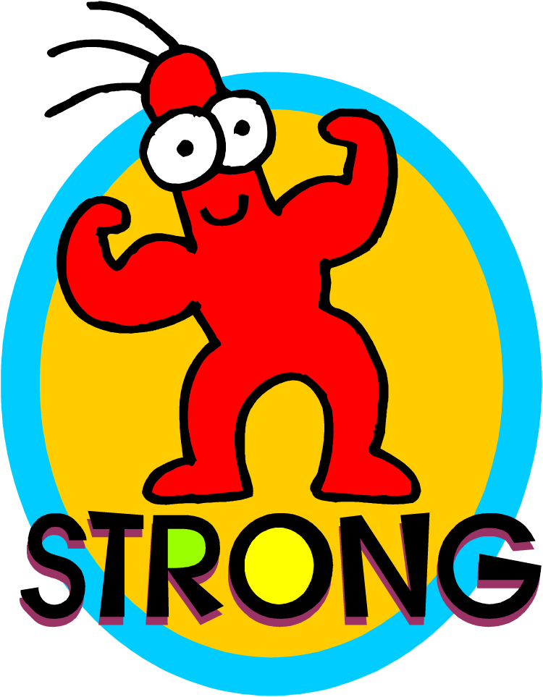  D OPINIONS
un étudiant | a student |  | fort en | good at
le patron | the boss |  | fatigant | tiring
professeur | teacher |  | bien payé | well paid
agent de police | police man |  | mal payé | badly paid
homme d’affaires | business man |  | intéressant | interesting
femme d’affaires | business woman |  | varié | varied
au chômage | unemployed |  | facile | easy
vétérinaire |   vet |  | agréable | 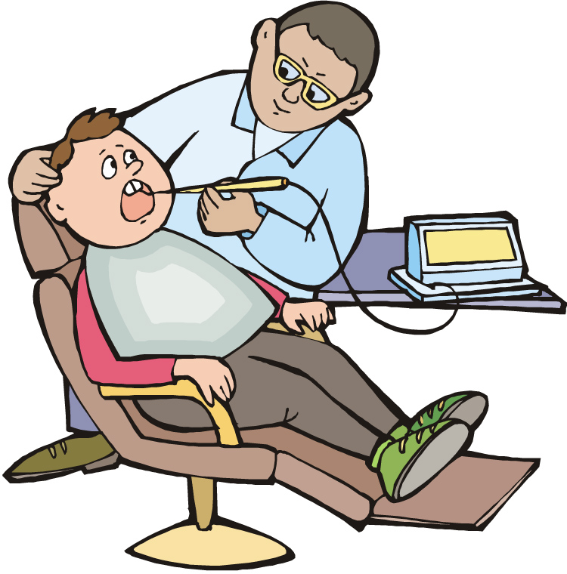  pleasant
médecin | doctor |  | pas mal | not bad
docteur | doctor |  | dur | hard
dentiste | dentist |  | affreux | awful
secrétaire | secretary |  | passionnant | exciting
receptionniste | receptionist |  | chouette | great
fille au pair | au pair |  | faible en | weak at
vendeur | sales assistant (m) |  | vendeuse | sales assistant (f)
coiffeur | hairdresser (m) |  | coiffeuse | hair dresser (f)
serveur | waiter (m) |  | serveuse | waitress (f)
chanteur | 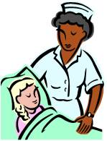  singer (m) |  | chanteuse |   singer (f)
boucher | butcher (m) |  | bouchère | butcher (f)
infirmier | nurse (m) |  | infirmière | nurse (f)
fermier | farmer |  | fermière | farmer (f)
boulanger | baker (m) |  | boulangère | baker (f)
caissier | check out assistant (m) |  | caissière | check out assistant (f)
cuisinier | cook (m) |  | cuisinière | cook (f)

A thorough knowledge of vocabulary is essential for making progress in French. We recommend that pupils spend a little time (5-10mins) every evening memorizing vocabulary.
Could you please sign and date this vocabulary sheet to say you are satisfied that your son/daughter has learnt these words to your satisfaction. Many thanks.

__________________________________________________ _____________________________

