A. MASCULINE | A. ADJECTIVES |  | B. FEMININE | B. ADJECTIVES
beau | beautiful |  | belle | beautiful
grand | big |  | grande | big
vieux | old |  | vieille | old
petit |   small |  | petite | small
nouveau | new |  | nouvelle | new
C. LOCATIONS | C. LOCATIONS |  | D. LOCATIONS | D. LOCATIONS
la vieille ville | the old town |  | se trouve | is situated
un quartier | a neighbourhood |  | près de | near
une grande ville | a city |  | loin de | far from
au centre-ville | In the town centre |  | environ | around
un vieux village | an old village |  | plus de | more than
un petit village | a little village |  | moins de | less than
une belle ville | a beautiful town |  | deux cent kilomètres | 200km
 |  |  | de Paris | from Paris
E. ADJECTIVES | E. ADJECTIVES |  | F. PREPOSITIONS | F. PREPOSITIONS
touristique | touristy |  | à côté de | next to
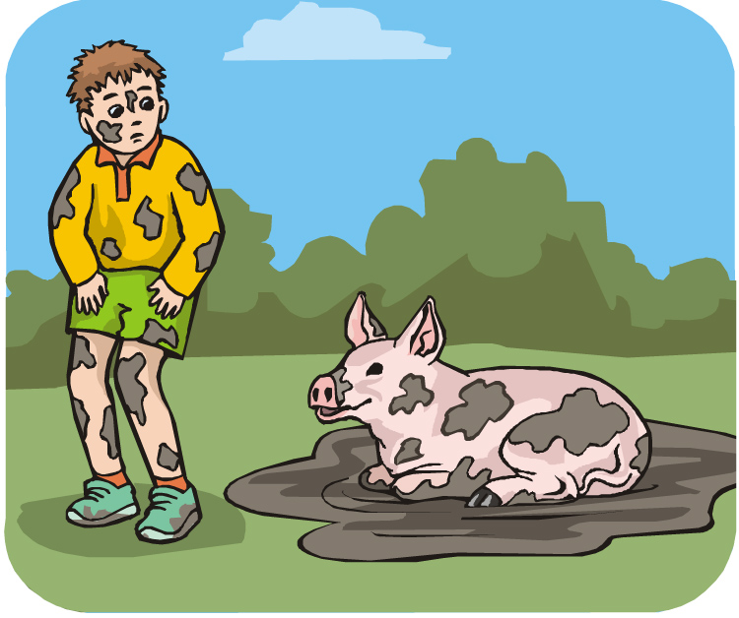  propre | clean |  | entre | between
sale | dirty |  | en face de | opposite
rurale | rural |  | près de | near to
industrielle | industrial |  | loin de | far from
  calme | peaceful
tranquille | peaceful |  | 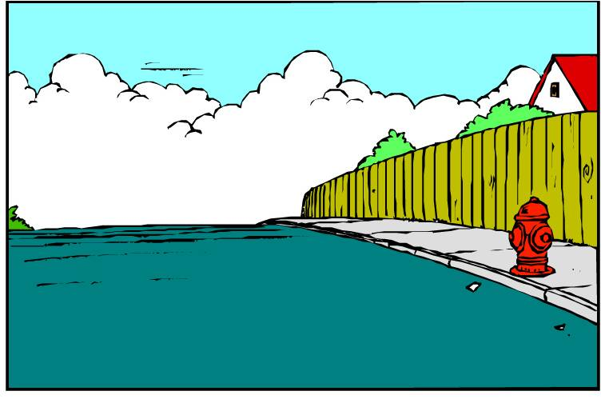  G. EXTRAS |   G. EXTRAS
historique | historical |  | la rue | the street
magnifique | magnificient |  | la route | the road
bruyant (e) |   noisy |  | la route nationale | main road (between towns)
animé (e) | lively |  | 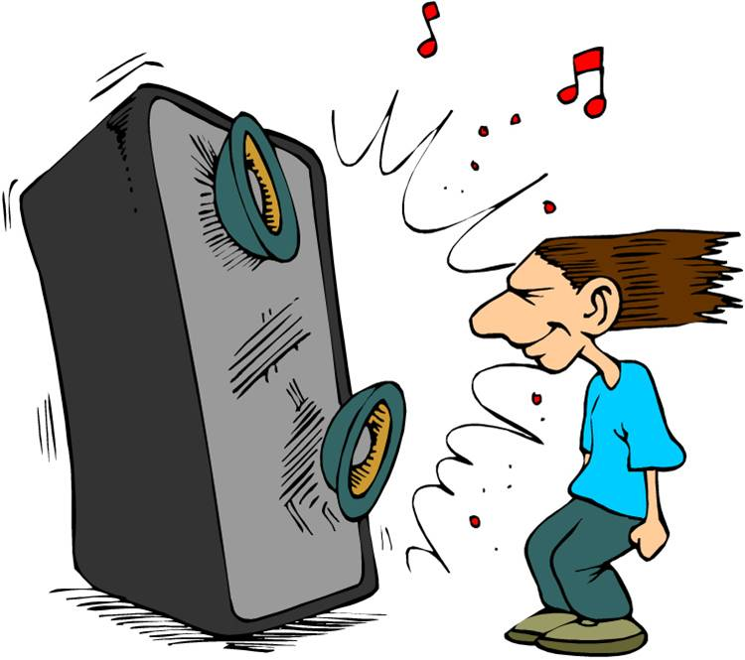  les habitants | inhabitants
joli (e) | pretty |  | le bruit | the noise
ancien (ne) | ancient |  | la circulation | the traffic
 |  |  | les transports en commun | public transport
 |  |  | les chose à faire | things to do
 |  |  | un embouteillage | a traffic jam
 |  |  | une autoroute | a motorway

