A shocking image of Syria's brutal war – a war that will continue regardless
Even the most horrific photos are not able to prevent wars happening, they remain decoration for our conscience Jonathan Jones theguardian.com, Friday 28 February 2014
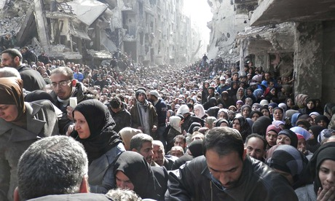
Refugees queue for food parcels in Yarmouk, Syria. Photograph: Handout/Reuters
This week the Guardian published the kind of picture that deserves to change the world. The front page of Thursday's print edition was dominated by an epic scene of human suffering, reproduced above. In a canyon between grey shattered precipices of bomb-ravaged buildings, an uncountable number of people wait for food. The faces in the front of the vast desperate crowd are anxious, stoical, subdued; beyond is a sea of heads whose expressions are unreadable but guessably similar.
This is a great photograph – and it wants the world to act. It was released by the UN agency for Palestinian refugees and shows what happened when aid workers tried to give out food parcels at Yarmouk refugee camp on the edge of Damascus. The picture illuminates the mind-boggling devastation of the war in Syria: tottering jumbles of concrete and plaster gaping with voids and caverns, are all that is left of this cityscape. Above all, it captures the sheer scale of human suffering with this horribly mesmerising sea of faces.
But will it make a difference? It is intended as a campaigning picture, not a work of art. Here are the facts from one small part of Syria; here is the fate of part of the Palestinian people.
When I look at photographs that try to move the world to compassionate action I am haunted by Jurgen Stroop. In the 1940s, Stroop, the SS General who led the final attack on the Warsaw ghetto, collected some singularly devastating images of human suffering. They show the final defeat of the Jewish uprising in the ghetto in 1943. In one picture, soldiers, who happen to be Ukrainian, stand over the bodies of Jews killed in the fighting. In another, a factory burns. In another, people are being marched to a checkpoint to be taken to the camps. These images are harrowing, easily as harrowing as this week's picture from Damascus – for the victims here are all going to be murdered, not fed – and yet they were not taken to save lives, to move the world to action.
Stroop was accompanied by a photographer whose pictures illustrated an elegantly produced report that Stroop sent to Himmler, entitled The Jewish Quarter No Longer Exists, and the album shows why photographs don't stop wars or end suffering. The images he preserved are today part of the testimony of the Holocaust: few could look at them, surely, without feeling gut instincts of anger and compassion. Yet we know that their first onlookers contemplated them with satisfaction at a job well done – the extermination of race enemies.
The problem with photography that tries to wake up the world to conflict and suffering is that cruel and violent human situations come about precisely because ideologies ignore reality and blind themselves to others' pain. If the first casualty of war is truth, what is the use of pictures that appeal to a universal human court of justice and righteousness? We aspire to that common humanity, but war in its vicious modern forms comes about precisely because it is so easy to deny it even to your neighbours.
The impotence of images to shake the world to its senses was demonstrated in the first war that became a modern "issue", an international cause of debate and handwringing and taking sides. Robert Capa's photographs from the Spanish Civil War are unequivocally compassionate and empathetic with the people of Madrid enduring fascist air raids – but they were not enough to turn the tide and save the Republican cause. They surely helped to recruit idealists to fight for Spain – but Franco won anyway.
Capa was later one of the founders of Magnum Photos and died in Indochina, forming a human bridge between the age of the world wars and the post-1945 era in which humane photojournalism has become part of the fabric of modern conflict. Where there are wars there are heroes with cameras, seeing the horror on behalf of humanity. Larry Burrows in Vietnam, Don McCullin in Cyprus and Biafra – these are among the great witnesses of the modern age.
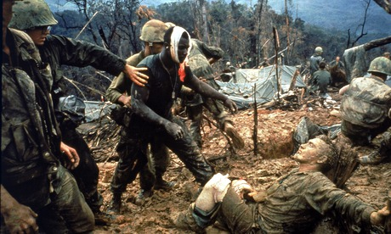Wounded marine gunnery sergeant Jeremiah Purdie (centre) with stricken comrades in south Vietnam, 1966. Photograph: Larry Burrows/Time & Life Pictures/Getty Image
But wars and war crimes go on. And photography just seems to be a decoration for our conscience. We don't act because of photographs. There is no need to go far back in history to illustrate this depressing truth. Only last year, photographs on the front pages of newspapers around the world showed the bodies of children killed in a poison gas attack in Syria. The global debate provoked by these pictures ended in a considered decision not to intervene militarily. The House of Commons was widely congratulated by liberals for its refusal to take aggressive action. So why fool ourselves? We look at the terrors of our time and are shocked, but it's just fine feelings. Because this is not a well-governed world, there is no will to make it one, and as things stand, no curb on human cruelty.

